## 6.5. Service Identity & Authentication

### Introduction to IAM 3 minutes -https://youtu.be/mB1yJAVa4qw

* + 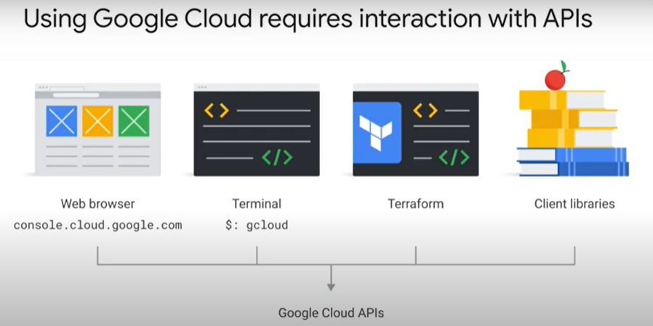
  + 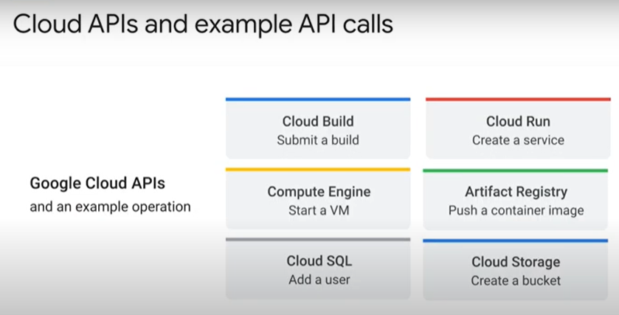
  + 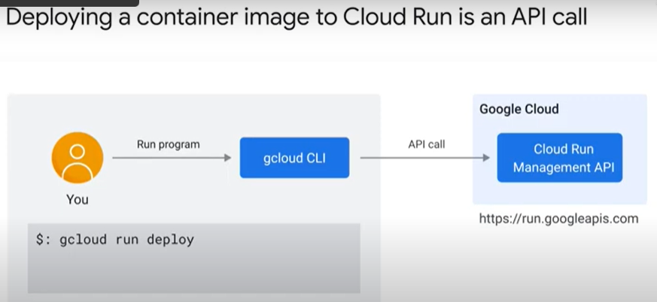
  + 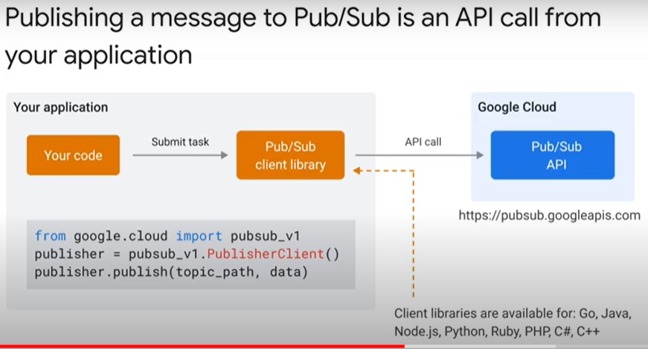
  + 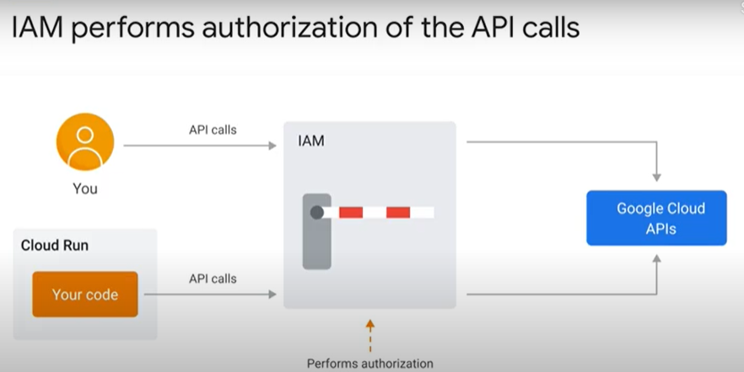
* IAM Policy 4 minutes - <https://youtu.be/yIM7S3NCUfg>
  + 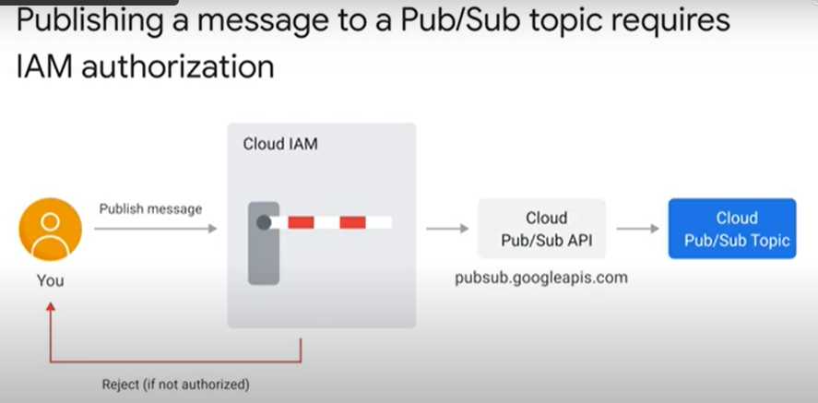
  + 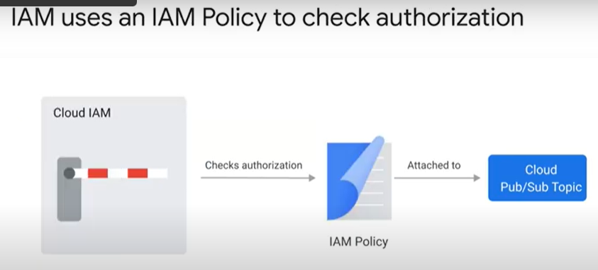
  + 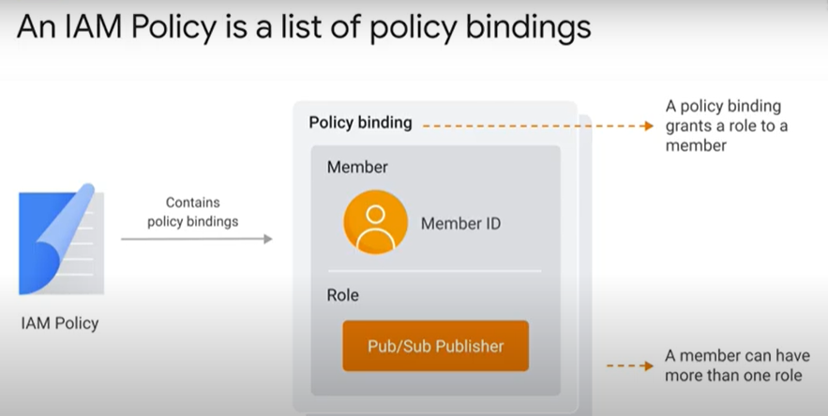
  + 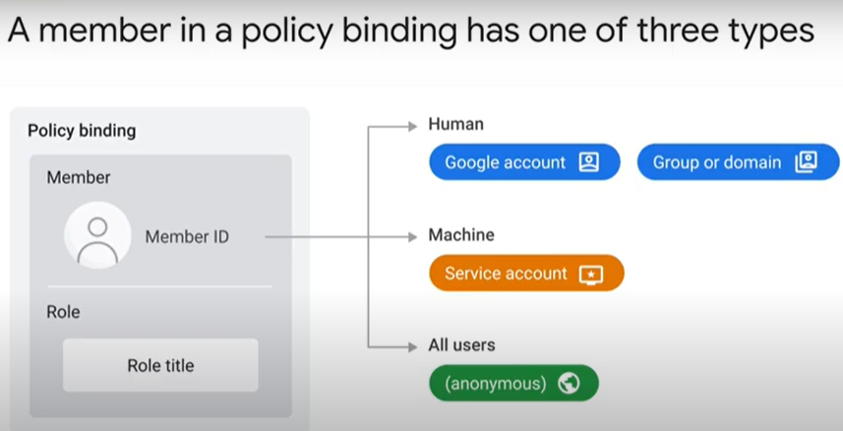
  + 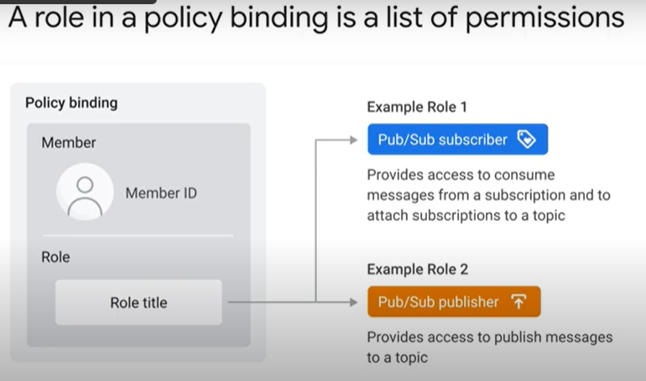
  + 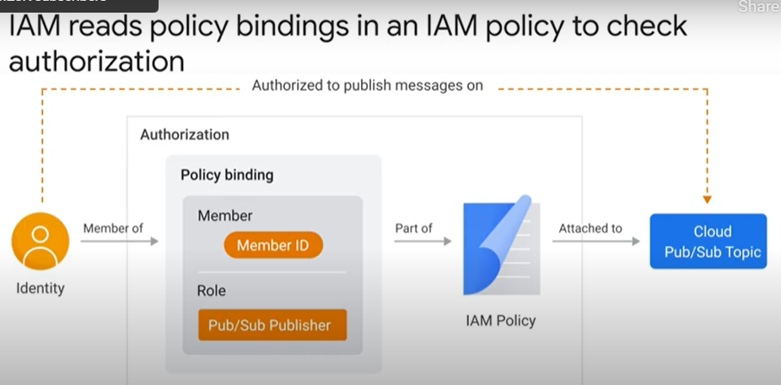
  + 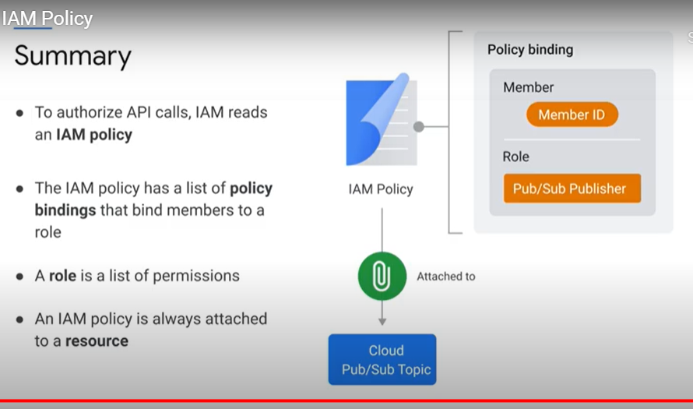
* Service identity 1 minute - <https://youtu.be/J4VHpGJd3gc>
  + 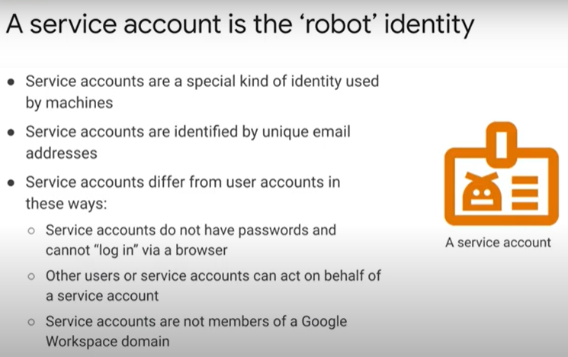
  + 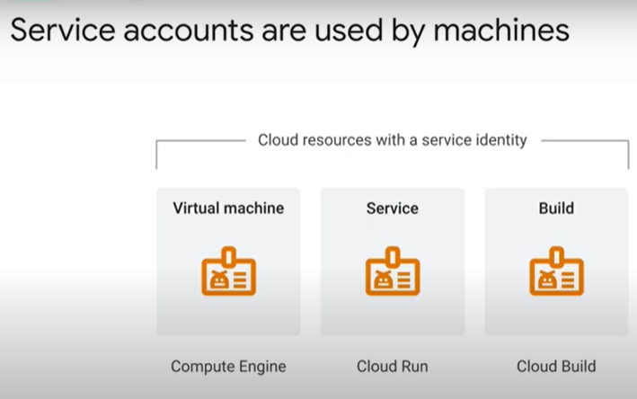
  + 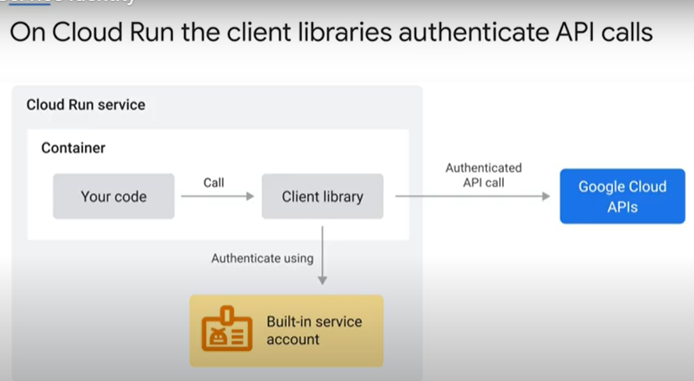
* Resource hierarchy 3 minutes - <https://youtu.be/ZmhUmfNK2jI>
  + 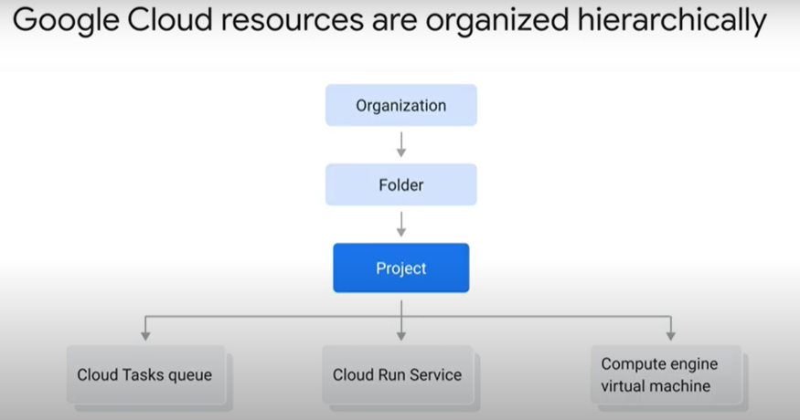
  + 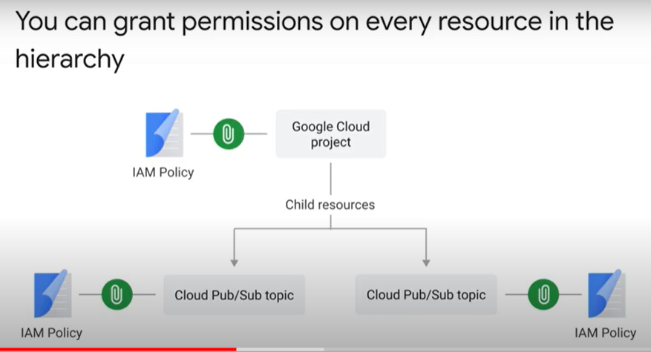
  + 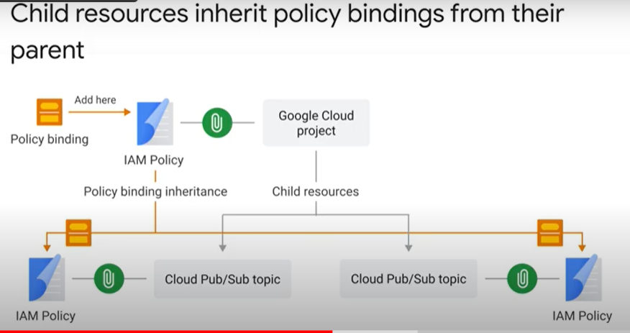
  + 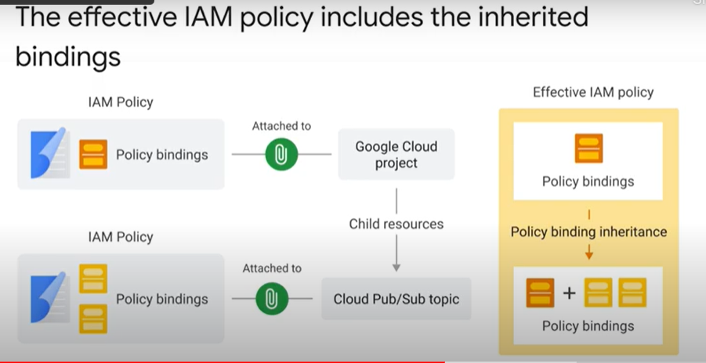
  + 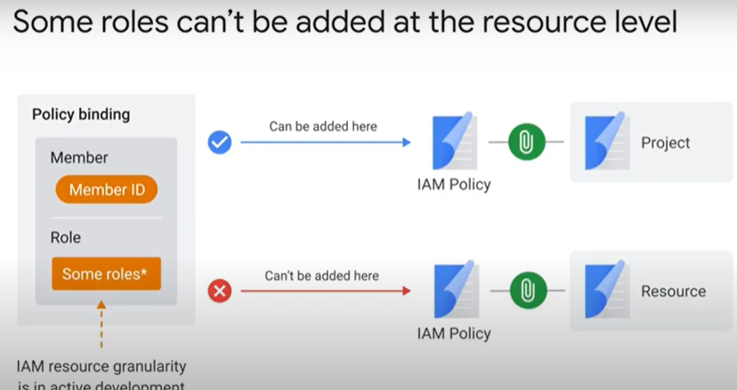
  + 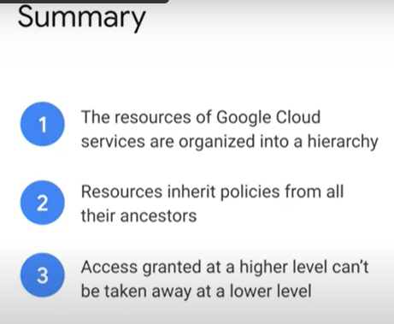
* Least privilege 2 minutes - <https://youtu.be/DzIM9f9j1Hs>
  + 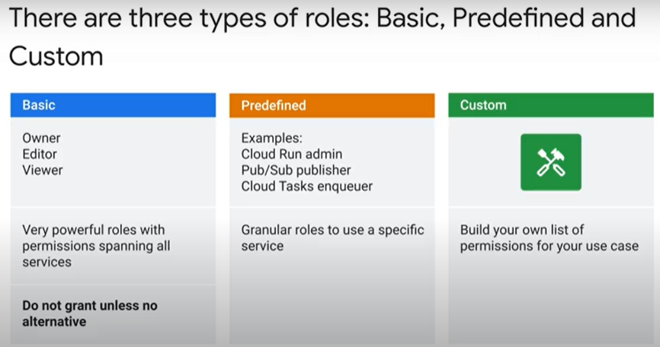
  + 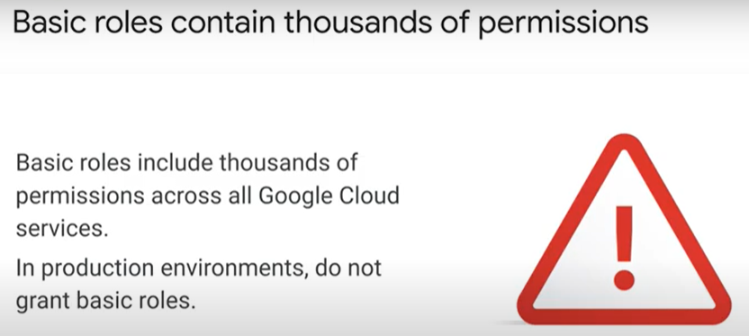
  + 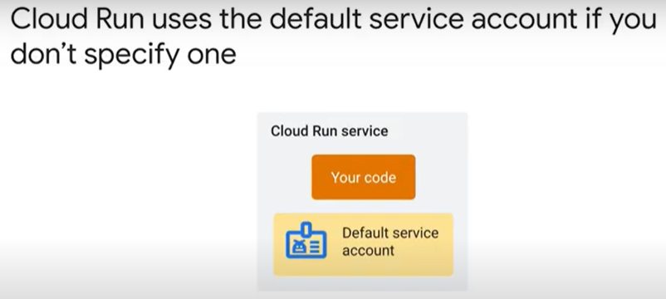
  + 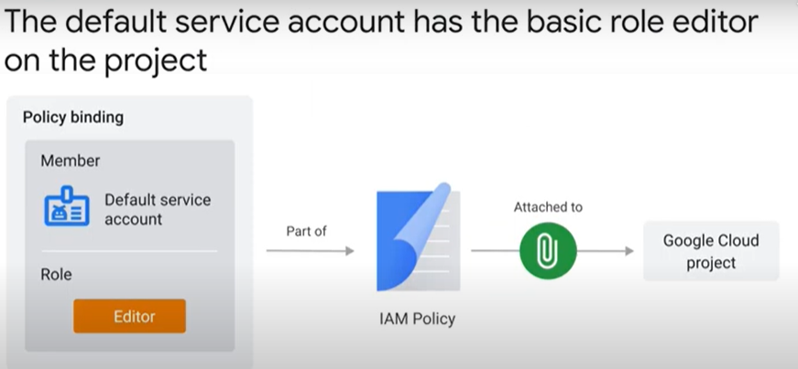
  + 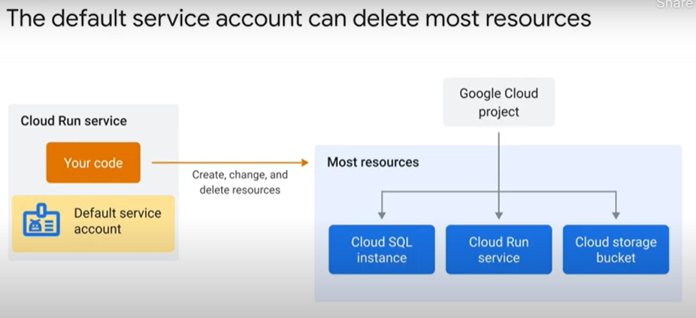
  + 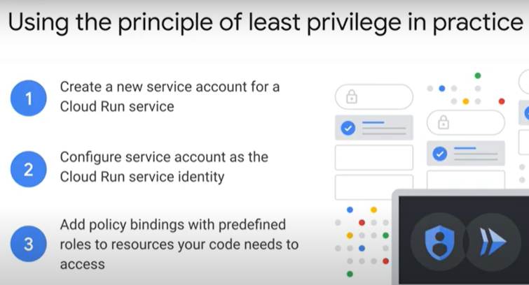
  + 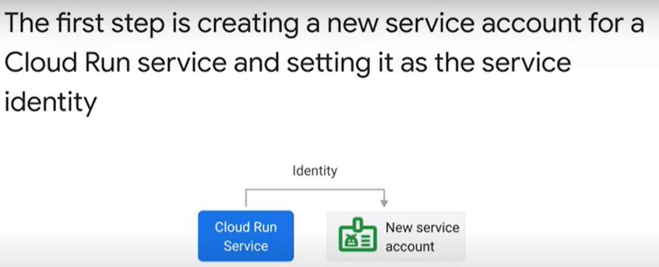
  + 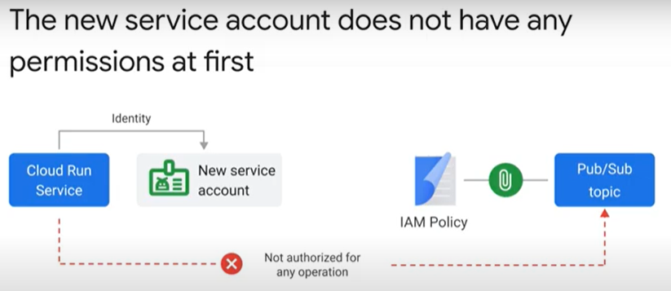
  + 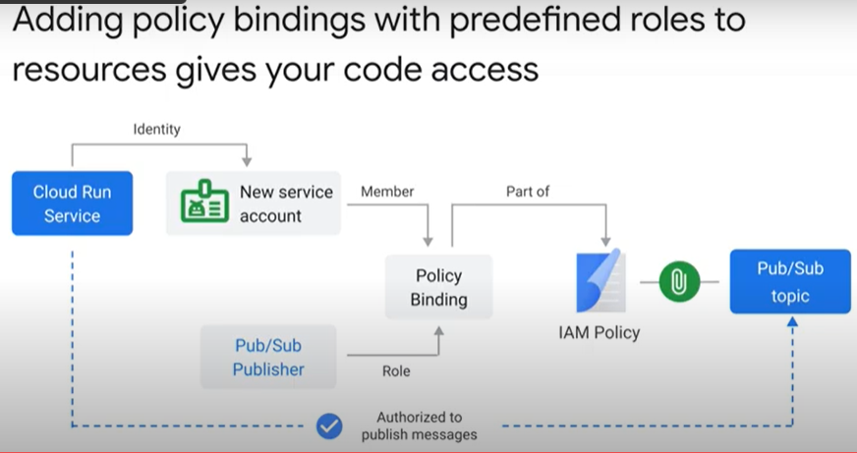
* Demo 10 minutes - https://youtu.be/jSDkG53TkiU

### Implementing Least Privilege IAM Policy Bindings in Cloud Run [APPRUN] 45 minutes

* + Objectives
    - Configure your environment, including enabling the Cloud Run API
    - Create and deploy a public Cloud Run service
    - Authenticate service requests.
    - Invoke a non-public Cloud Run service from another service account.
  + Configure the environment
    - gcloud services enable run.googleapis.com
    - gcloud config set run/region us-central1
    - LOCATION="us-central1"
  + Task 1. Create and deploy a public service
    - Requirements
      * Quickway parking has a Cloud Run billing service that they would like to be made more secure. The component is called over the internet using an assigned URL, but will need eventually to be able to be called from a scheduling service. In this lab you will:
        + Deploy the Billing Service from an image
        + Adjust the permissions to the URL
        + Set up more secure authentication using a Service Account
    - Deploying with Cloud Run
      * The Quickway DevOps team already has a billing image available on Google Cloud. Open Cloud Shell and deploy this Cloud Registry image.
      * Deploy the Billing Service:
        + gcloud beta run deploy quickway-parking-billing-v1 \
        + --image gcr.io/qwiklabs-resources/gsp723-parking-service \
        + --region $LOCATION \
        + --allow-unauthenticated
      * Assign the URL for the new service to an environment variable:
        + QUICKWAY_SERVICE=$(gcloud run services list \
        + --format='value(URL)' \
        + --filter="quickway")
      * In the Cloud Run section of the Cloud Console, select the name of the service just deployed.
        + 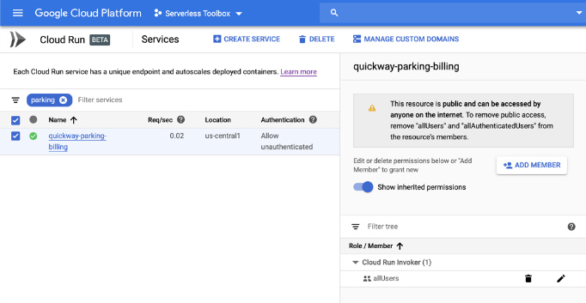
      * It looks like the Security team has spotted something in the security settings. Can you see what part of the above configuration has them so concerned?
      * Hint: Google Cloud promotes least privilege permissions. Unfortunately, the billing service has a wider scope than necessary.
      * Take a closer look at the authentication applied and the role permissions assigned. At the moment, both the Cloud Scheduler and anyone on the internet can call the billing service!
        + 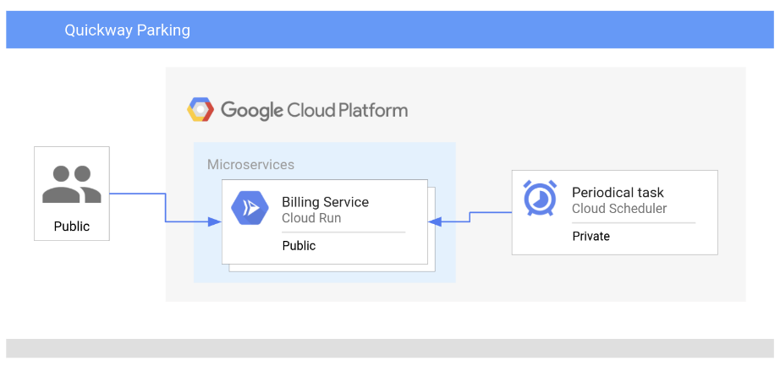
      * When the Billing service was originally deployed it used the --allow-unauthenticated permission, which means "make the service publicly available".

|  |  |  |
| --- | --- | --- |
| **Type** | **Permission** | **Description** |
| URL Access | --allow-unauthenticated | Make the service PUBLIC (i.e. Unauthenticated users can see it). |
| Invoke Permission | allUsers | Allow the service be invoked/triggered by anyone. |

* + - * By removing the --allow-unauthenticated permission you can use the Cloud Run default permissions to secure the service.

|  |  |  |
| --- | --- | --- |
| **Type** | **Permission** | **Description** |
| URL Access | --no-allow-unauthenticated | Make the service PRIVATE (i.e. Authenticated users can see it). |
| Invoke Permission | none | Do not allow the service to be invoked/triggered by anyone. |

* + - * Note: Remember, with Google Cloud, always try to use least privilege permissions in your solution.
      * Making these changes means the Security team is a lot happier with the overall design.
      * The team updates the application design to show how the changes will work:
      * 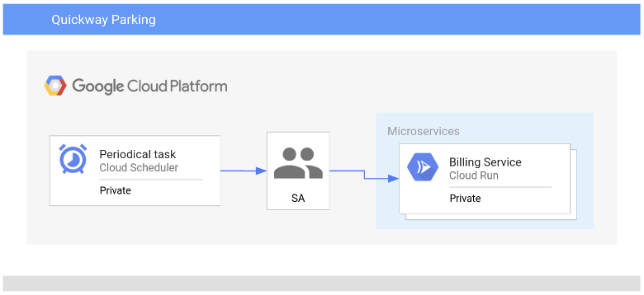
      * The main changes are:
        + Remove unauthenticated access and invoke permission associated with Billing service.
        + Create a new Service Account with permissions to invoke the Billing service.
  + Task 2. Authenticating service requests
    - Now that you understand more about the permissions used with Cloud Run, correct the authentication permissions applied to the Billing service:
    - Delete the existing deployed Billing service:
      * gcloud run services delete quickway-parking-billing-v1
    - If prompted for (Y/n), press Y and then Enter.
    - Redeploy the Billing service with --no-allow-authenticated:
      * gcloud run deploy quickway-parking-billing-v2 \
      * --image gcr.io/qwiklabs-resources/gsp723-parking-service \
      * --region $LOCATION \
      * --no-allow-unauthenticated
    - Redeploying the billing service means it no longer allows unauthenticated access via its URL. In addition, the access permission to invoke the service via the URL has been removed.
    - Defining a Service Account
      * What if you need to be able to invoke a non-public Cloud Run service from another service account? In that case, you will need to add permissions to "invoke" your Billing application from the new service, using IAM policy bindings.
      * This can be done via the Console, or by using the command line interface. We will use the Console in this lab to set up the new policy binding for the Billing service.
      * In the Cloud Console, select IAM & Admin > Service Accounts. Create a new Service Account that will provide authenticated access by clicking on Create Service Account near the top of the menu.
      * Create a new Service Account called Billing Initiator.
        + Click the Create and Continue button to create the account and advance to the Grant Access step.
      * Select the Role dropdown, scroll the left side to Cloud Run, and select the role Cloud Run Invoker to give the Billing Initiator permissions to invoke the Billing Service.
      * Select Continue and then Done to complete the setup of the Service Account. You will see the new service account at the top of your list of service accounts in the Console window.
      * The service account, "Billing Initiator" has been created, and it has now been given authorization to invoke a Cloud Run instance, using an IAM policy binding.
* Quiz
  + Which of the following statements is true about IAM: (select all that apply)
    - An IAM policy is a list of policy bindings that bind members to roles
    - An IAM policy is attached to a resource
  + If you create a Cloud Run service, the default service account is used. What role is given to this service by default?
    - Editor
  + How do you achieve the principle of least privilege on Cloud Run?
    - Create a new service account for every Cloud Run service and selectively grant permissions

## 6.6. Serving Requests

### Global HTTPS Load Balancer 4 minutes - <https://youtu.be/HaBUrr8Ym2w>

* + 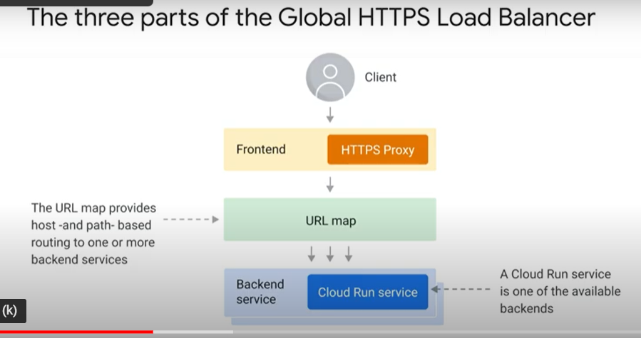
  + 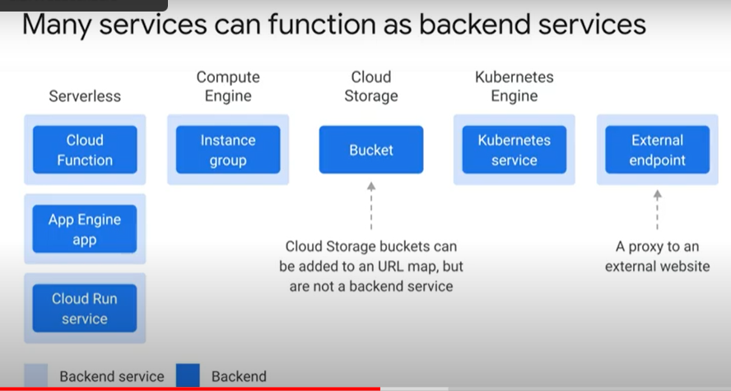
  + 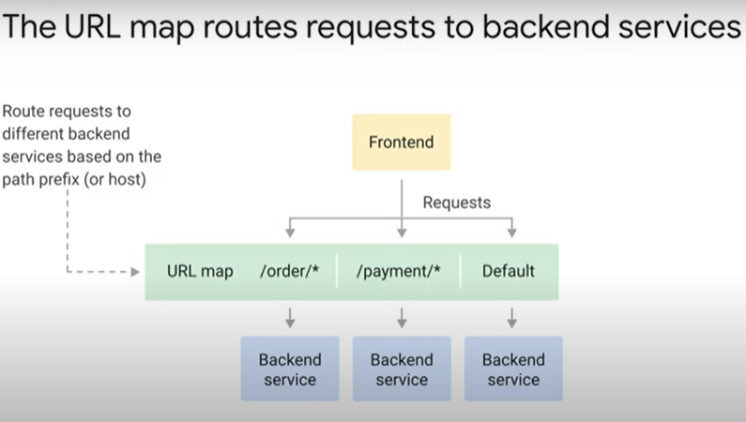
  + 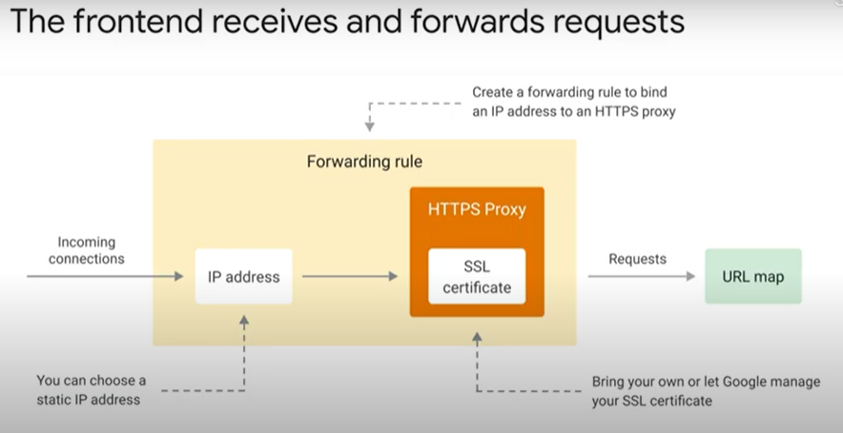
  + 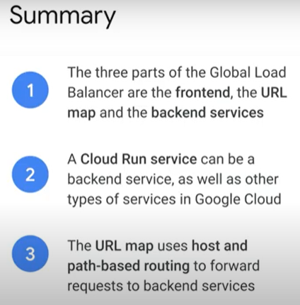
* Cloud CDN 2 minutes -https://youtu.be/0ojiumOLRMc
  + 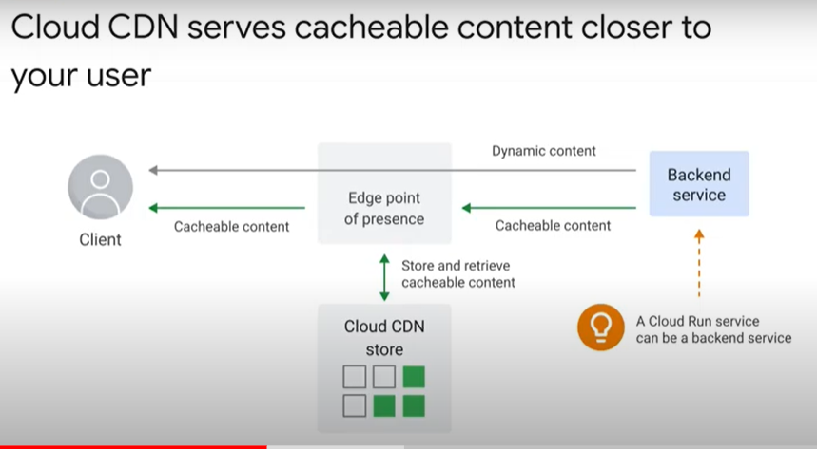
  + 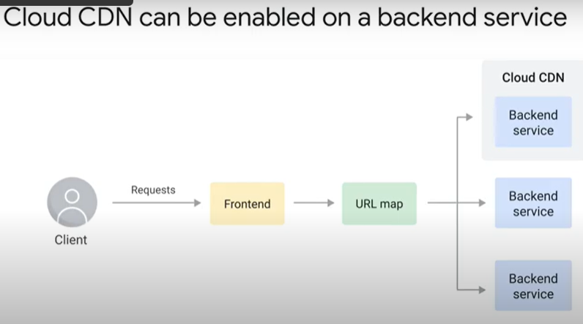
  + 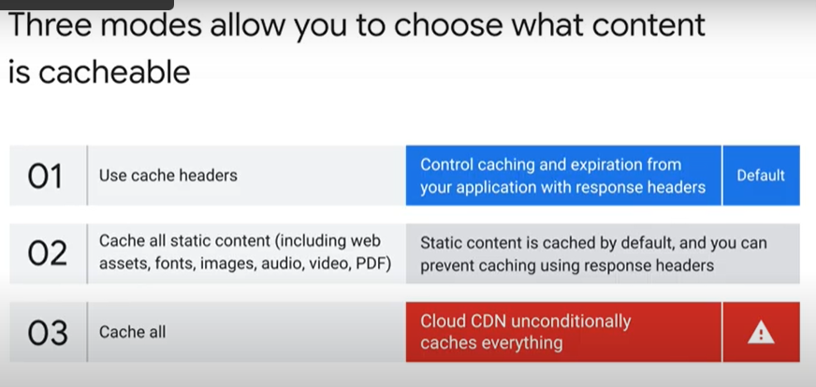
  + 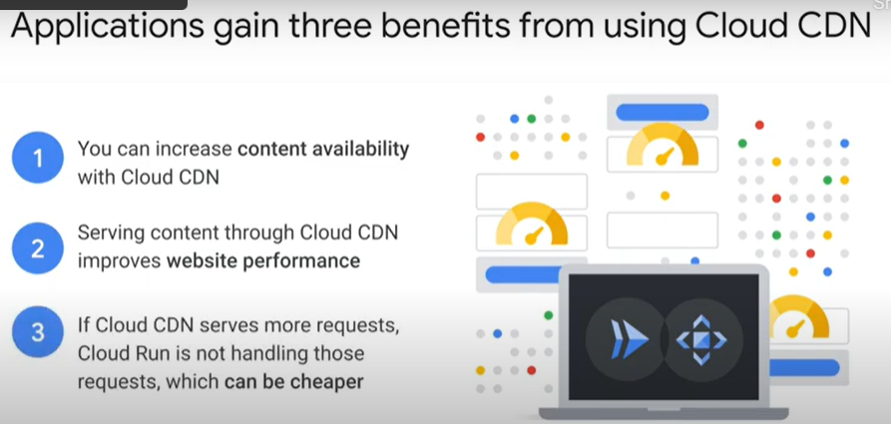
* Multi-regional applications 4 minutes - <https://youtu.be/LXXuFT4VPVU>
  + 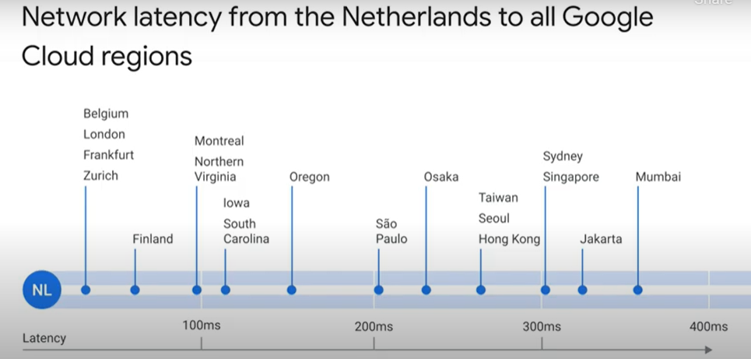
  + 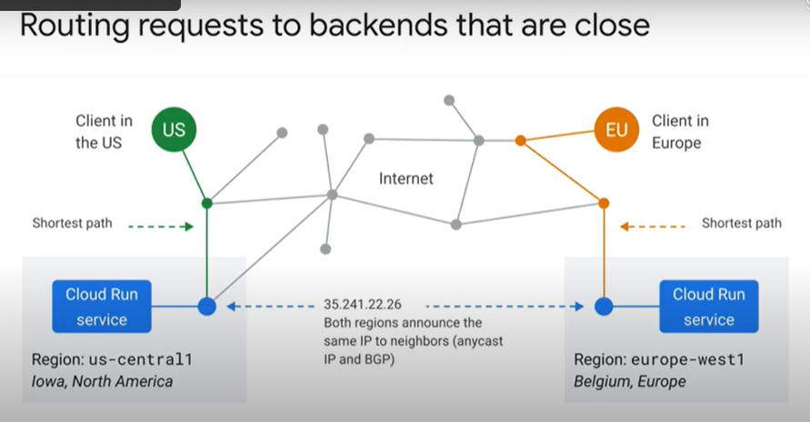
  + 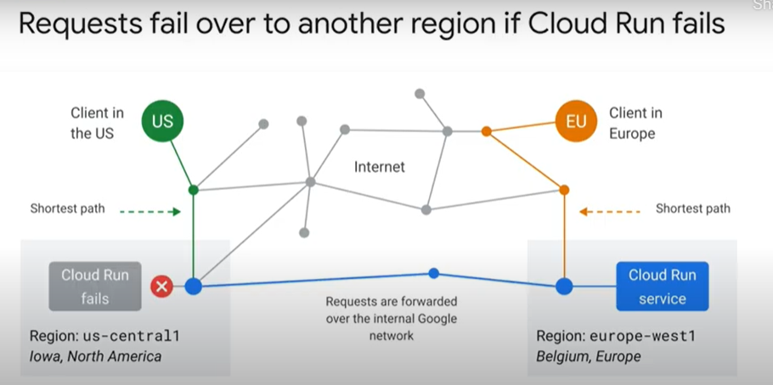
  + 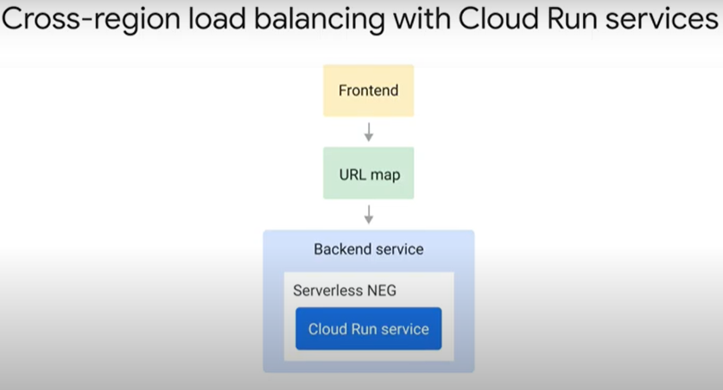
  + 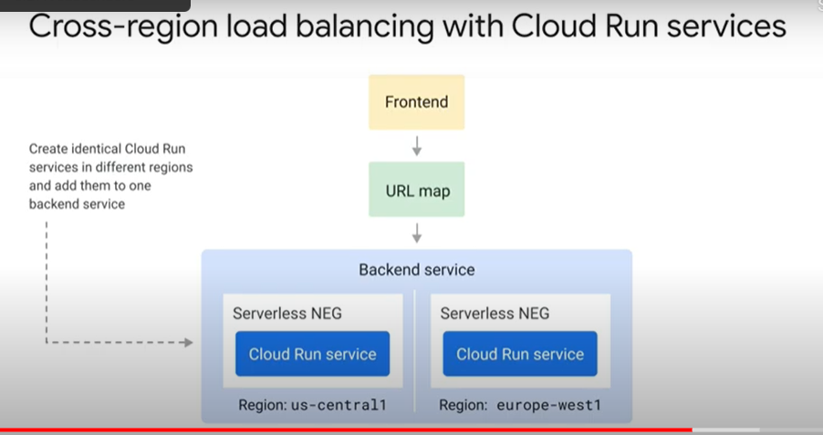
  + 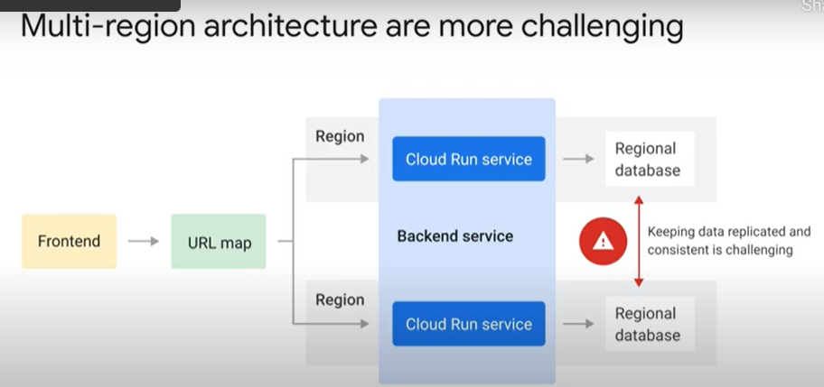
  + 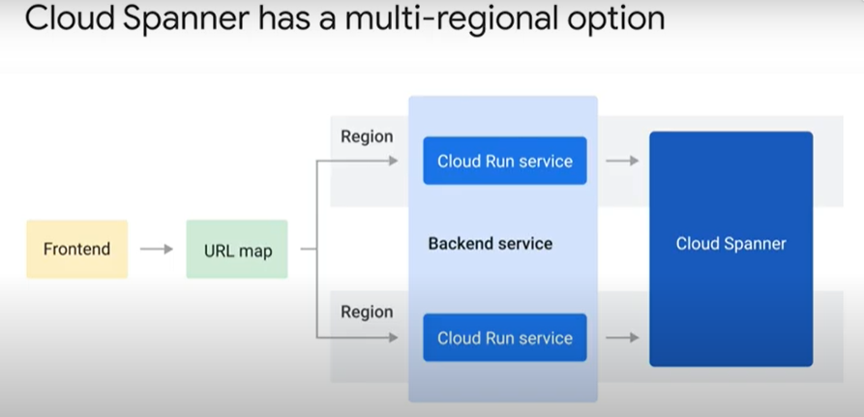
* Host and path-based routing 3 minutes -https://youtu.be/4vRoQfK4pGc
  + 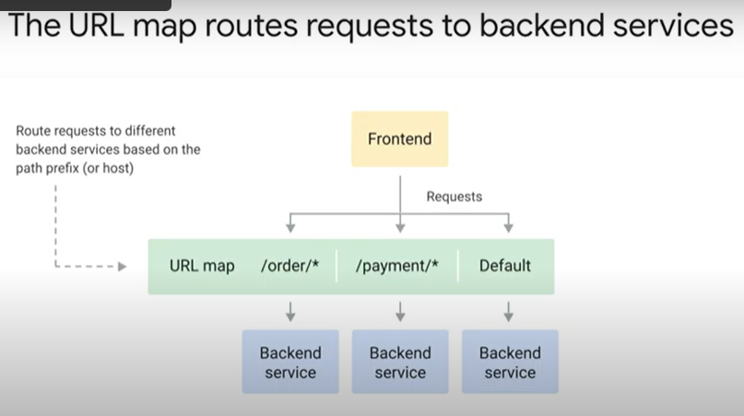
  + 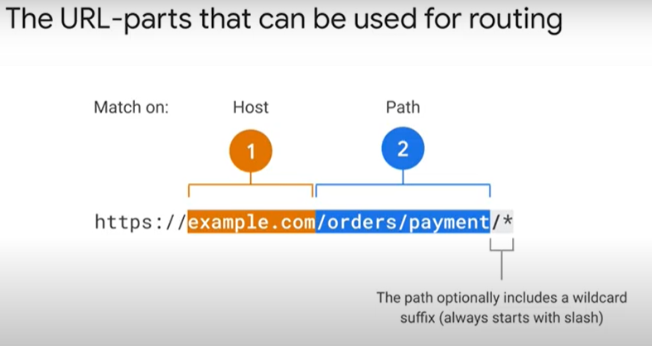
  + 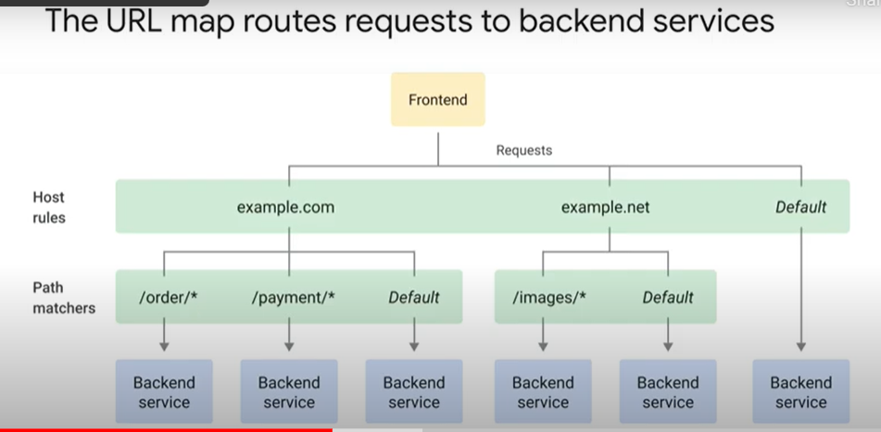
  + 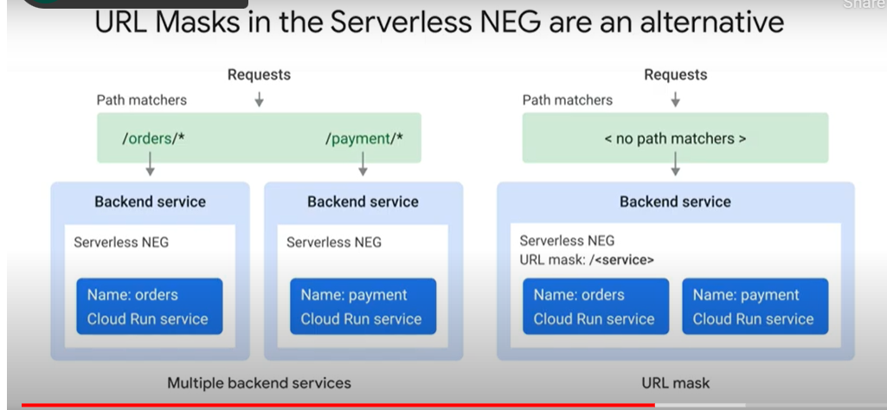
  + 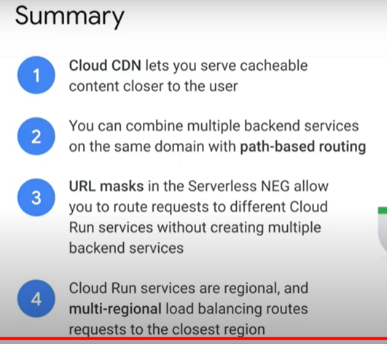

### Using a Global Load Balancer with Cloud Run [APPRUN] 1 hour

* + Objectives
    - Enable the Cloud Run API.
    - Create and deploy a sample application in Cloud Run.
    - Configure a Serverless Network Engpoint Group (NEG).
    - Create a global load balancer with a serverless NEG backend.
    - Route requests for the sample application through the global load balancer.
  + Overview
    - * 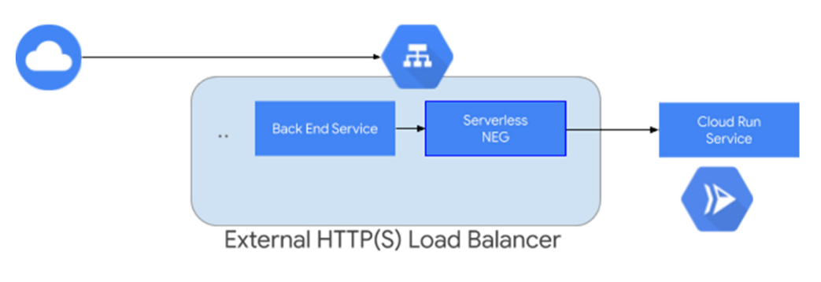
    - Serverless Network Endpoint Groups (NEGs) allow you to use Google Cloud serverless apps with external HTTP(S) Load Balancing. After you have configured a load balancer with the serverless NEG backend, requests to the load balancer are routed to the serverless app backend.
  + Task 1. Configure the Environment
    - gcloud services enable run.googleapis.com
    - gcloud config set compute/region us-central1
    - gcloud config set run/region us-central1
    - LOCATION="us-central1"
  + Task 2. Write a simple application
    - For this lab, we will create a simple Cloud Run Python "Hello, World" app and deploy it as a Cloud Run service in the us-central1 region. This simple app will become the target for an external HTTP load balancer which will use a serverless NEG backend to route requests to that service.
    - In Cloud Shell create a new directory named helloworld, then move your view into that directory:
      * mkdir helloworld && cd helloworld
    - Create a main.py file, then add the following content to it:
      * import os
      * from flask import Flask
      * app = Flask(__name__)
      * @app.route("/")
      * def hello_world():
      * name = os.environ.get("NAME", "World")
      * return "Hello {}!".format(name)
      * if __name__ == "__main__":
      * app.run(debug=True, host="0.0.0.0", port=int(os.environ.get("PORT", 8080)))
    - This code responds to requests on port 8080 with a "Hello World" greeting.
    - Your app is now finished and ready to be containerized and uploaded to Container Registry.
  + Task 3. Containerize your app and upload it to Container Registry (Artifact Registry)
    - To containerize the sample app you just made, create a new file named Dockerfile in the same directory as the main.py file, and add the following content :
      * # Use the official lightweight Python image.
      * # https://hub.docker.com/_/python
      * FROM python:3.9-slim
      * # Allow statements and log messages to immediately appear in the Knative logs
      * ENV PYTHONUNBUFFERED True
      * # Copy local code to the container image.
      * ENV APP_HOME /app
      * WORKDIR $APP_HOME
      * COPY . ./
      * # Install production dependencies.
      * RUN pip install Flask gunicorn
      * # Run the web service on container startup. Here we use the gunicorn
      * # webserver, with one worker process and 8 threads.
      * # For environments with multiple CPU cores, increase the number of workers
      * # to be equal to the cores available.
      * # Timeout is set to 0 to disable the timeouts of the workers to allow Cloud Run to handle instance scaling.
      * CMD exec gunicorn --bind :$PORT --workers 1 --threads 8 --timeout 0 main:app
    - This Python Dockerfile starts a Gunicorn web server which listens on the port defined by the PORT environmental variable set in the main.py file (port 8080).
    - Now, build your container image using Cloud Build, by running the following command from the directory containing the Dockerfile:
      * gcloud builds submit --tag gcr.io/$GOOGLE_CLOUD_PROJECT/helloworld
    - Upon success, you will see a SUCCESS message containing the image name (gcr.io/PROJECT-ID/helloworld). The image is now stored in Container Registry and can be deployed in the next task.
    - Note: You can ignore any warning while building the container image using Cloud Build.
  + Task 4. Deploy your container to Cloud Run
    - Now that we have our containerized image, we will need to use the gcloud command below to deploy it to Cloud Run. Replace PROJECT-ID with your GCP project ID. You can view your project ID by running the command gcloud config get-value project.
      * gcloud run deploy --image gcr.io/$GOOGLE_CLOUD_PROJECT/helloworld
    - The API should already be enabled, but if you are prompted to enable the API, Reply y.
    - You will then be prompted for the service name: press Enter to accept the default name, helloworld.
    - If prompted for region: in this case, select us-central1.
    - You will be prompted to allow unauthenticated invocations: respond y. Wait a few moments until the deployment is complete. Upon success, the command line displays the service URL.
    - Visit your deployed container by opening the service URL in a web browser.
  + Task 5. Reserve an external IP address
    - Now that your services are up and running, you need to set up a global static external IP address that your customers use to reach your load balancer.
    - A static external IP address provides a single address to point your serverless app to. Reserving an IP address would also be essential if you were using a custom domain for your serverless app.
    - Use the following command to reserve your static IP address:
      * gcloud compute addresses create example-ip \
      * --ip-version=IPV4 \
      * --global
    - To display the IP address that was just reserved, use:
      * gcloud compute addresses describe example-ip \
      * --format="get(address)" \
      * --global
    - Note this IP address, because you will need it later.
  + Task 6. Create the external HTTP load balancer
    - Load balancers use a serverless Network Endpoint Group (NEG) backend to direct requests to a serverless Cloud Run service. So, let's first create our serverless NEG for our serverless Python app created earlier in this lab.
    - To create a serverless NEG with a Cloud Run service, enter the following in Cloud Shell:
      * gcloud compute network-endpoint-groups create myneg \
      * --region=$LOCATION \
      * --network-endpoint-type=serverless \
      * --cloud-run-service=helloworld
    - Now, we need to create a backend service:
      * gcloud compute backend-services create mybackendservice \
      * --global
    - And then add the serverless NEG as a backend to this backend service:
      * gcloud compute backend-services add-backend mybackendservice \
      * --global \
      * --network-endpoint-group=myneg \
      * --network-endpoint-group-region=$LOCATION
    - Finally, create a URL map to route incoming requests to the backend service:
      * gcloud compute url-maps create myurlmap \
      * --default-service mybackendservice
    - If you had more than one backend service, you could use host rules to direct requests to different services based on the host name, or you could set up path matchers to direct requests to different services based on the request path. None of this is necessary here because we have only created one backend service for this lab.
    - Now, create a target HTTP(S) proxy to route requests to your URL map:
      * gcloud compute target-http-proxies create mytargetproxy \
      * --url-map=myurlmap
    - Create a global forwarding rule to route incoming requests to the proxy:
      * gcloud compute forwarding-rules create myforwardingrule \
      * --address=example-ip \
      * --target-http-proxy=mytargetproxy \
      * --global \
      * --ports=80
  + Task 7. Test your external HTTP load balancer
    - You can test your HTTP load balancer by going to http://IP_ADDRESS, where IP_ADDRESS is the load balancer's IP address you reserved earlier in this lab. When you open this URL, you should see the helloworld service homepage.
* Quiz
  + What are the three building blocks of the global load balancer?
    - The frontend, the URL map, and the backend services
  + Serving content through Cloud CDN improves website performance because:
    - You serve static content closer to the user, which reduces latency
  + Cross-region load balancing is useful when: (select all that apply)
    - You want to route requests to the closest Cloud Run servicer
    - You want to improve the availability of your application

## 6.7. Controlling Inbound & Outbound Requests

### Google Cloud Armor 2 minutes - <https://youtu.be/MLdQDO21Nac>

* + 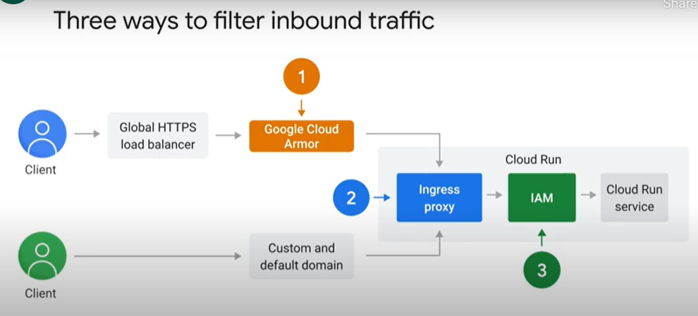
  + 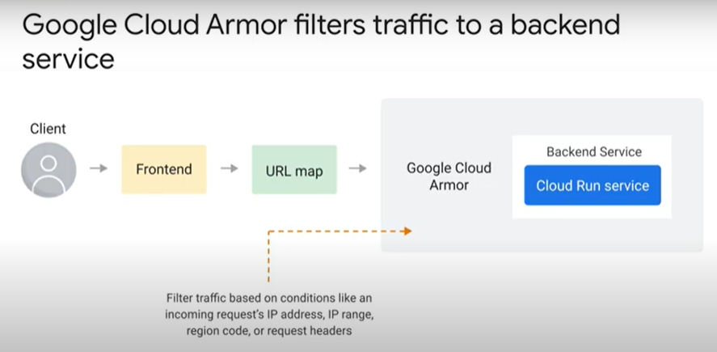
  + 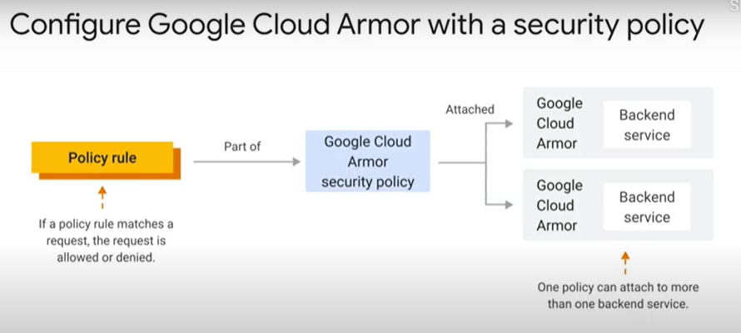
* Ingress settings 3 minutes - <https://youtu.be/S132j9Yho_Q>
  + 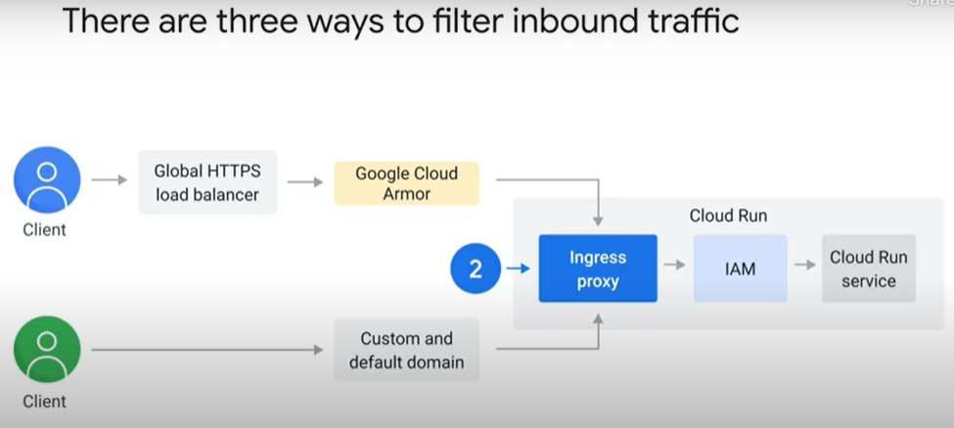
  + 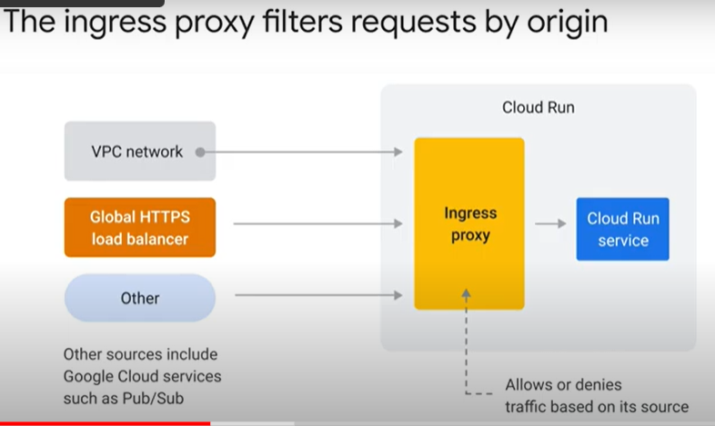
  + 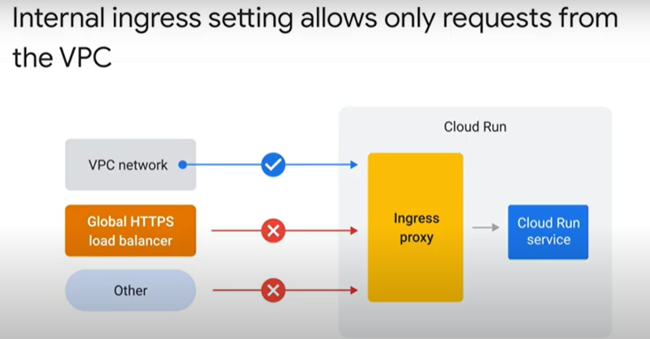
  + 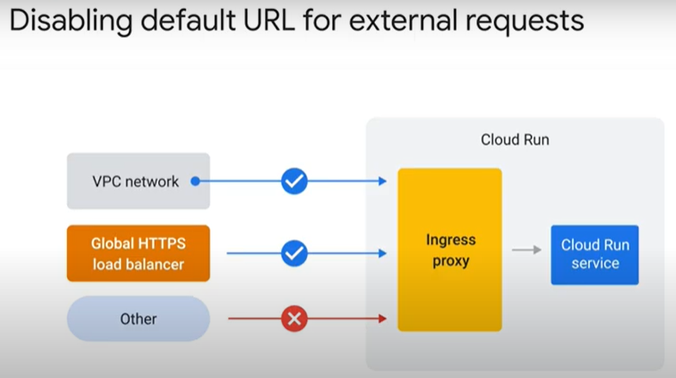
  + 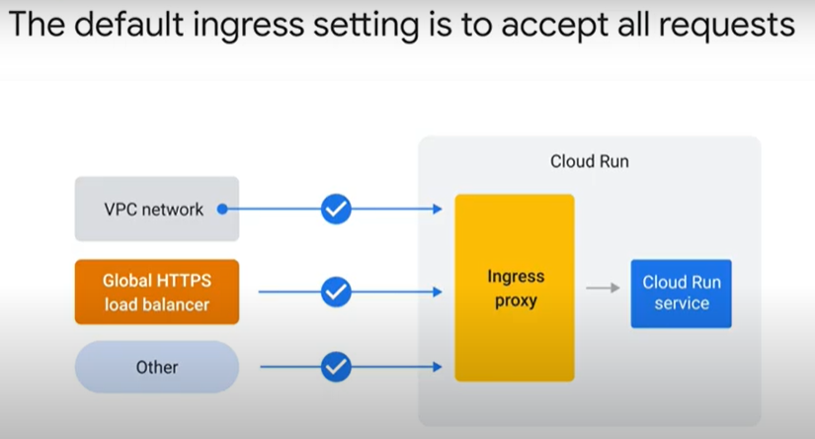
* IAM 5 minutes - <https://youtu.be/wL-ZZZB8qQw>
  + 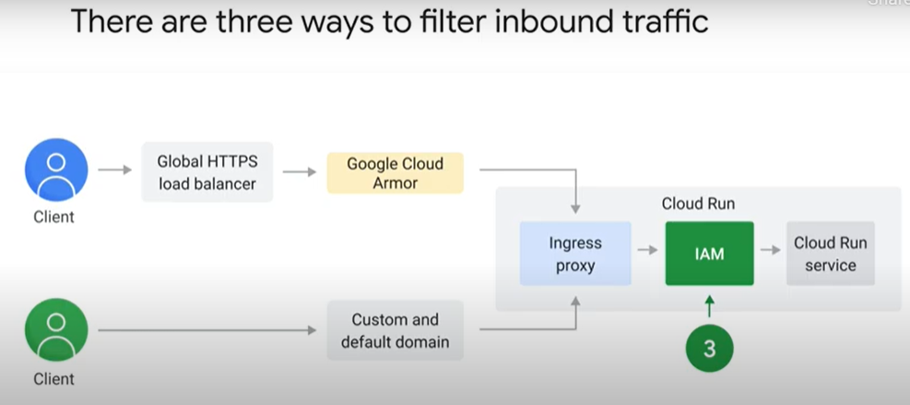
  + 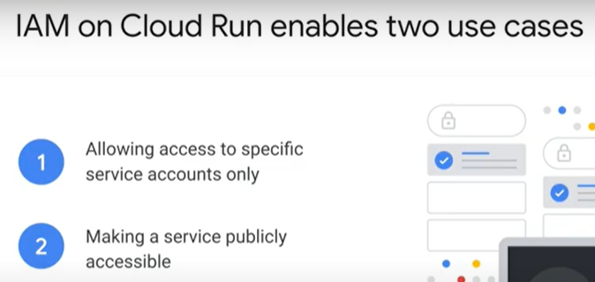
  + 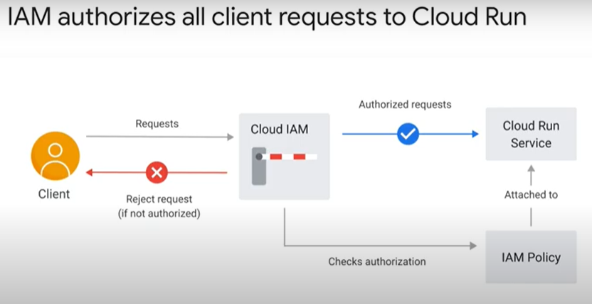
  + 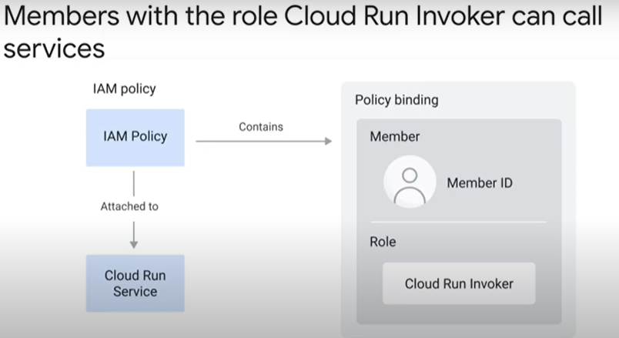
  + 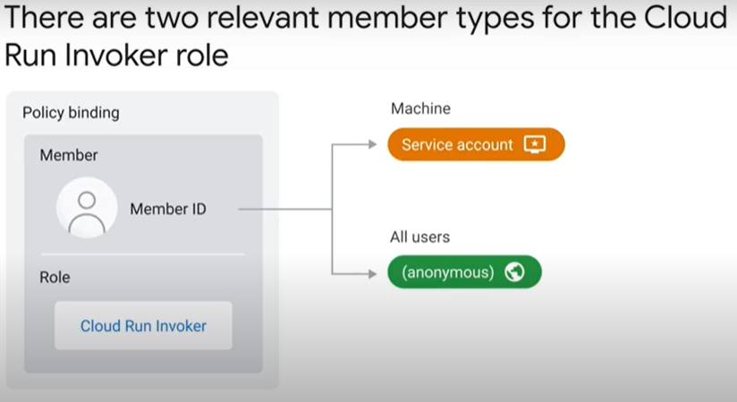
  + 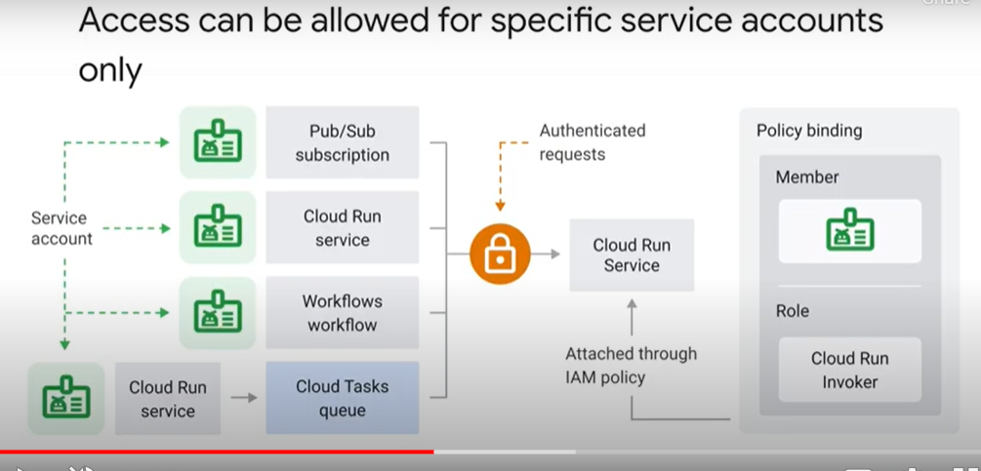
  + 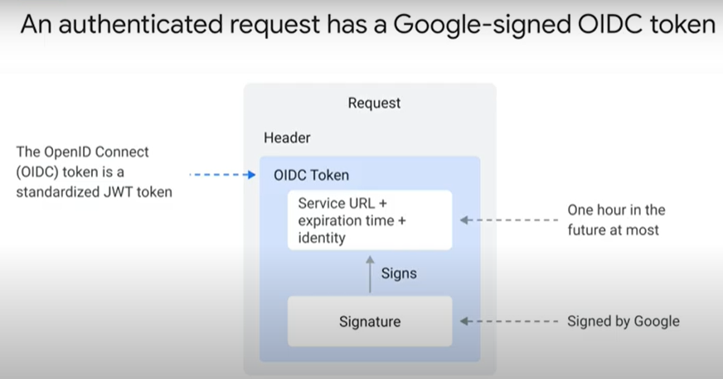
  + 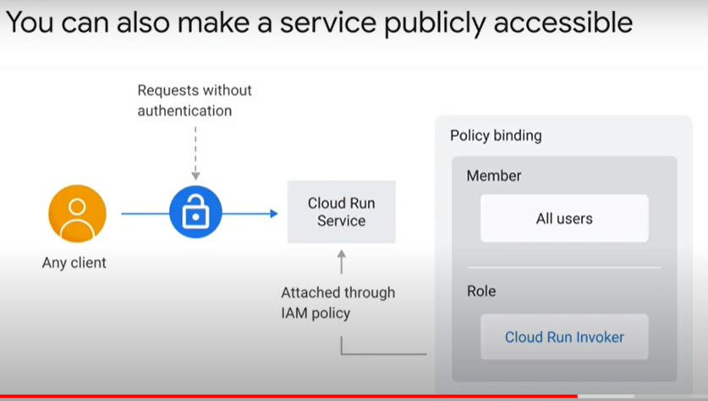
  + 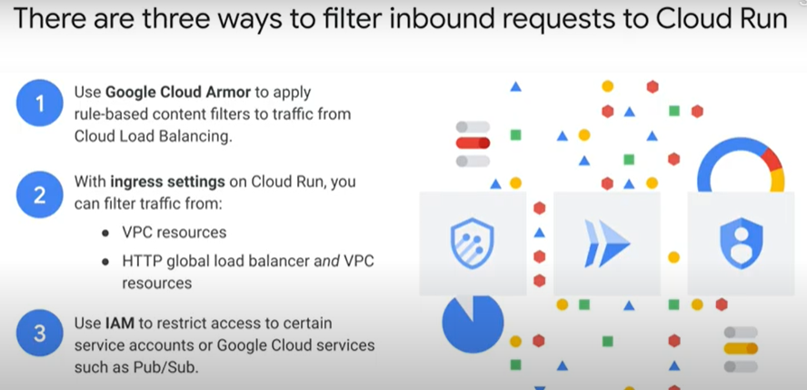
* Serverless VPC Access 4 minutes - <https://youtu.be/1OEQQVZ6A8U>
  + 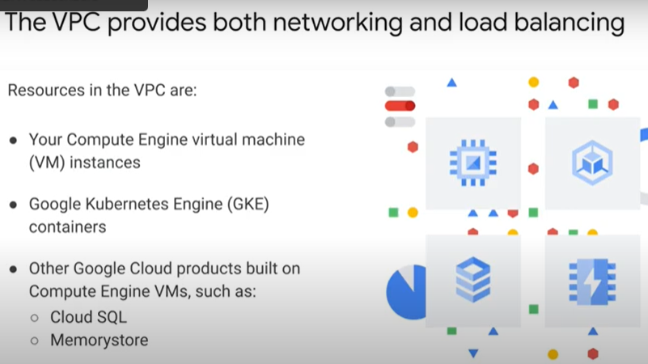
  + 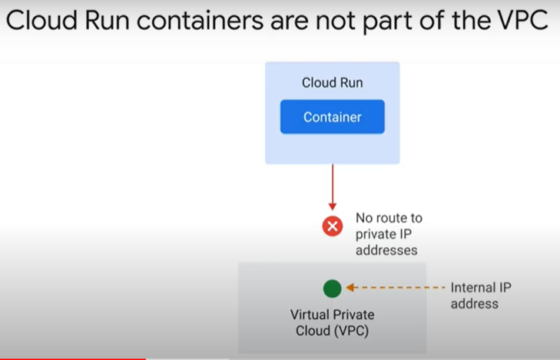
  + 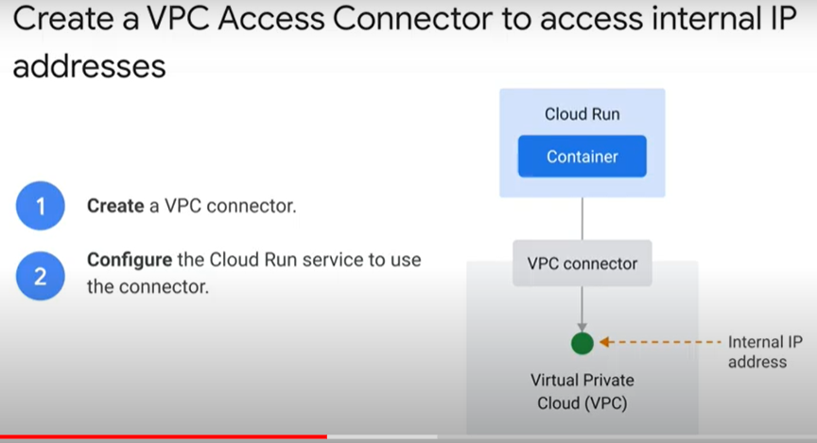
  + 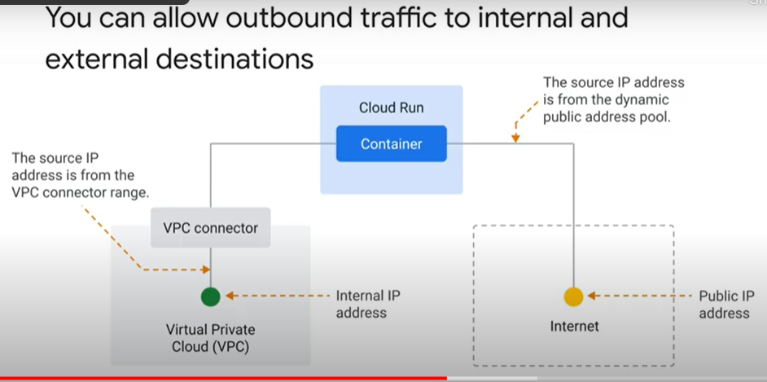
  + 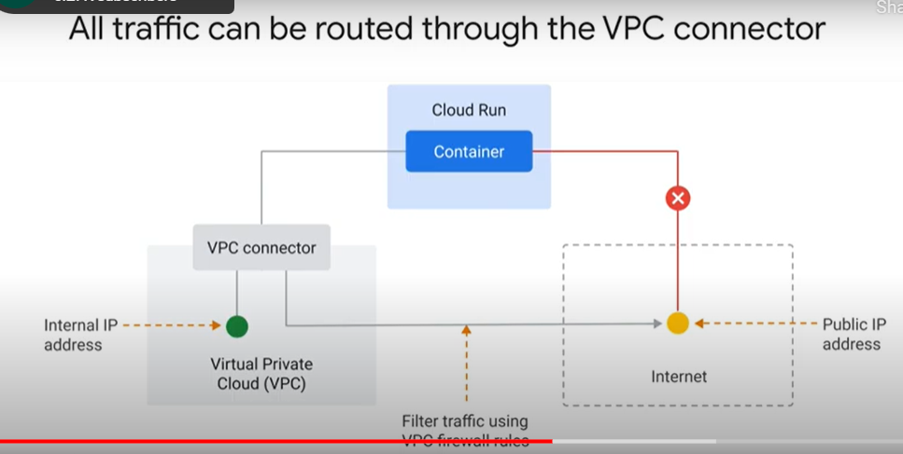
  + 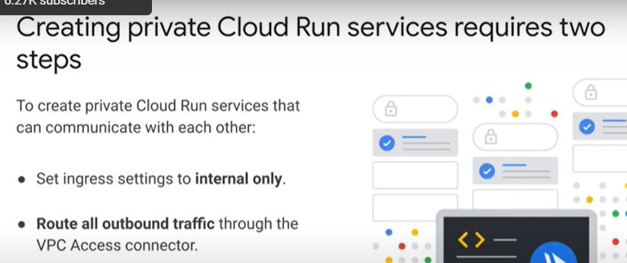
  + 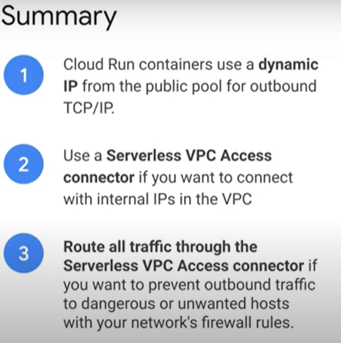

### Configuring Egress from a Static Outbound IP Address [APPRUN] 1 hour

* + Objectives
    - Build and publish a sample Cloud Run service and image using code from the Buildpack samples repository.
    - Create a subnetwork and a VPC access connector.
    - Configure network address translation (NAT).
    - Route your Cloud Run traffic through the VPC network.
  + Overview
    - By default, a Cloud Run service will connect to external endpoints on the internet using a dynamic IP address pool. This method is not suitable if the Cloud Run service needs to connect to an external endpoint that requires connections originating from a static IP address, for example, as a database or API using an IP address-based firewall. For those types of connections, you must configure your Cloud Run service to route requests through a static IP address.
    - This lab teaches the process of configuring a Cloud Run service to send requests using a static IP address.
  + Task 1. Enable the Cloud Run API and configure your Shell environment for flexibiilty
    - gcloud services enable run.googleapis.com
    - gcloud config set compute/region us-central1
    - LOCATION="us-central1"
  + Task 2. Create a Service
    - Clone the buildpack-samples repository, build an application container, Run, view web pewview
      * git clone https://github.com/GoogleCloudPlatform/buildpack-samples.git
      * cd buildpack-samples/sample-go
      * pack build --builder=gcr.io/buildpacks/builder sample-go
      * docker run -it -e PORT=8080 -p 8080:8080 sample-go
    - publish this image so you can use it later. First, set Buildpack as your default Builder, for convenience:
      * pack set-default-builder gcr.io/buildpacks/builder:v1
    - Finally, publish your image.
      * pack build --publish gcr.io/$GOOGLE_CLOUD_PROJECT/sample-go
  + Task 3. Create a Subnetwork
    - Creating a subnetwork for your Serverless VPC Access connector to reside in ensures that other compute resources in your VPC, such as Compute Engine VMs or Google Kubernetes Engine clusters, do not accidentally use the static IP you have configured to access the internet.
    - Create a subnetwork called mysubnet with a range of 192.168.0.0/28 (CIDR format is required for this), in the region us-central1, to be used as the VPC for your Serverless VPC Access connector. Use the command below, which will create this subnetwork in the project's default network (note also that subnets used for VPC connectors must have a netmask of 28, or you will get an error later in the process):
      * + gcloud compute networks subnets create mysubnet \
        + --range=192.168.0.0/28 --network=default --region=$LOCATION
  + Task 4. Create a Serverless VPC Access connector
    - To route your Cloud Run service's outbound traffic to a VPC network, you first need to set up a Serverless VPC Access connector.
    - Create a Serverless VPC Access connector named myconnector with your previously created subnetwork named mysubnet using the following command:
      * gcloud compute networks vpc-access connectors create myconnector \
      * --region=$LOCATION \
      * --subnet-project=$GOOGLE_CLOUD_PROJECT \
      * --subnet=mysubnet
    - You may be asked to enable the vpcaccess.googleapis.com on your project. If so, enter y and wait for the process to complete before proceeding.
  + Task 5. Configure network address translation (NAT)
    - To route outbound requests to external endpoints through a static IP (which is the main goal of this lab), you must first configure a Cloud NAT gateway.
    - Create a new Cloud Router to program your NAT gateway:
      * gcloud compute routers create myrouter \
      * --network=default \
      * --region=$LOCATION
    - Next, reserve a static IP address using the command below, where myoriginip is the name being assigned to your IP address resource.
    - A reserved IP address resource retains the underlying IP address when the resource it is associated with is deleted and re-created. Using the same region as your Cloud NAT router will help to minimize latency and network costs.
      * gcloud compute addresses create myoriginip --region=$LOCATION
    - To route outbound requests to external endpoints through a static IP, you must configure a Cloud NAT gateway.
    - Bring all of the resources you've just made together to create a Cloud NAT gateway named mynat. Use the command below to configure your router to route the traffic originating from the VPC network:
      * gcloud compute routers nats create mynat \
      * --router=myrouter \
      * --region=$LOCATION \
      * --nat-custom-subnet-ip-ranges=mysubnet \
      * --nat-external-ip-pool=myoriginip
  + Task 6. Route Cloud Run traffic through the VPC network
    - After NAT has been configured, you will deploy your Cloud Run service with the Serverless VPC Access connector and set the VPC egress to route all traffic through the VPC network:
      * gcloud run deploy sample-go \
      * --image=gcr.io/$GOOGLE_CLOUD_PROJECT/sample-go \
      * --vpc-connector=myconnector \
      * --vpc-egress=all-traffic
    - You may be asked to enable run.googleapis.com for your project. If so, respond y and wait for the API to enable. When asked for a region, choose us-central1 as the location "us-central1" is created in the environment variable and also choose y to allow unauthenticated invocations. It will take a few minutes for the process to complete.
    - If you are successful, after a few minutes, you should see output similar to that below:
    - Deploying container to Cloud Run service [sample-go] in project [qwiklabs-gcp-01-825e0adf46fc] region [us-central1]
      * ✓ Deploying new service... Done.
      * ✓ Creating Revision...
      * ✓ Routing traffic...
      * ✓ Setting IAM Policy...
      * Done.
      * Service [sample-go] revision [sample-go-00002-yax] has been deployed and is serving 100 percent of traffic.
      * Service URL: https://sample-go-lawvw7teya-uc.a.run.app
    - Click on the Service URL, and you will see the same "hello, world" message that you saw displayed in the web preview pane in Task 1.
* Quiz
  + You would attach a Serverless VPC Access connector to a Cloud Run service and route all egress traffic to the connector in order to (select all that apply):
    - Use a static outbound IP from connections from the Cloud Run service.
    - Prevent connections to unknown or dangerous hosts using the VPC firewall
  + To create internal Cloud Run services that can communicate only with each other, you should:
    - Route all outbound traffic through the VPC Access Connector and set ingress settings to internal only
  + You should use the ingress settings on Cloud Run to: (select all that apply)
    - Disable the default *.run.app URL or custom domains
    - Allow only incoming requests from resources in the VPC
  + With IAM on Cloud Run, you can: (select all that apply)
    - Allow access only to certain service accounts or Google Cloud services
    - Allow public access to a Cloud Run service

## 6.8. Persisting Data

### Connecting to Cloud SQL 7 minutes - <https://youtu.be/6xaR2Lej-2c>

* + 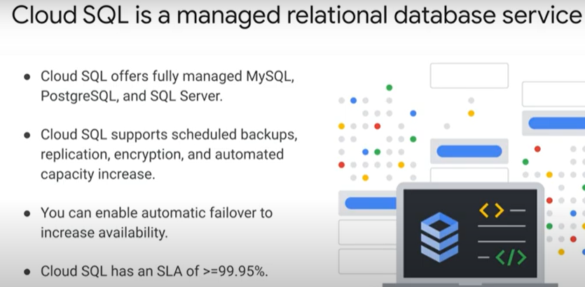
  + 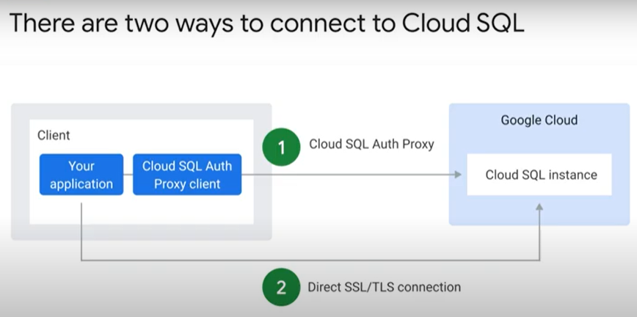
  + 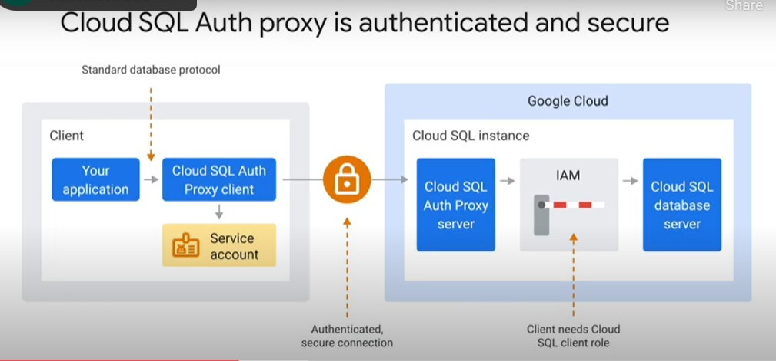
  + 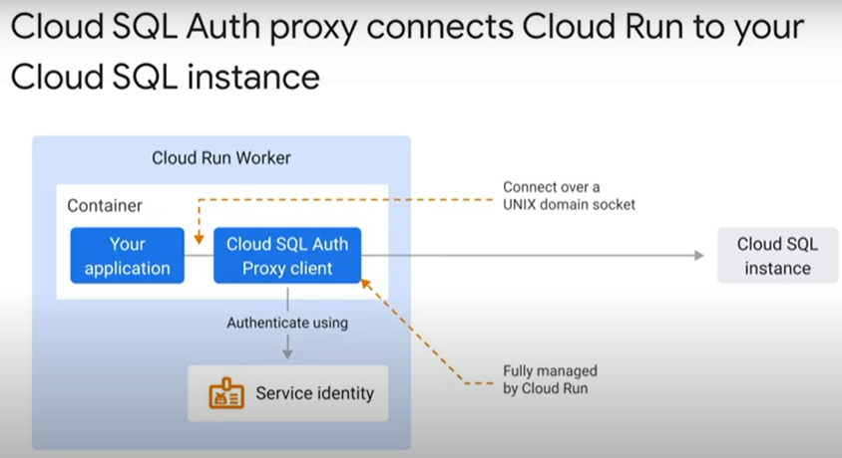
  + 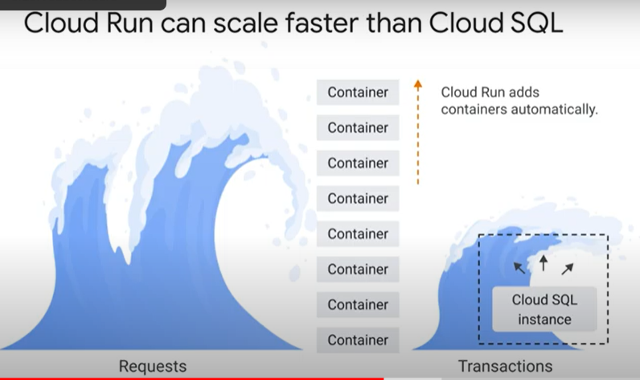
  + 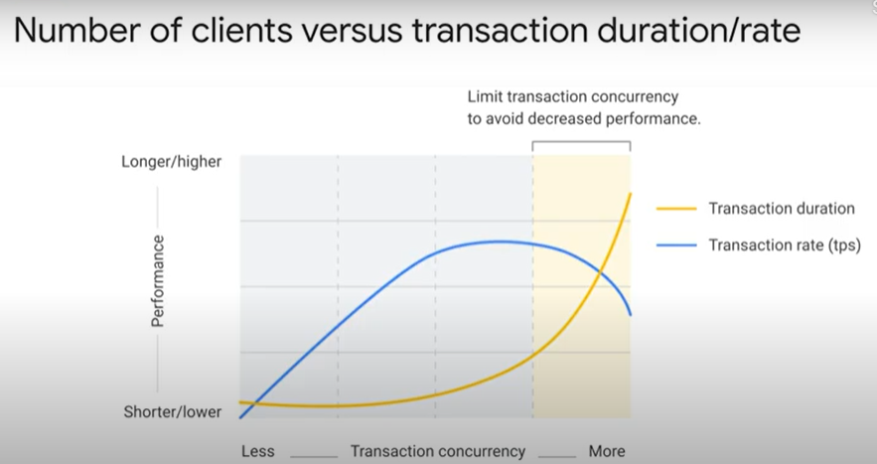
  + 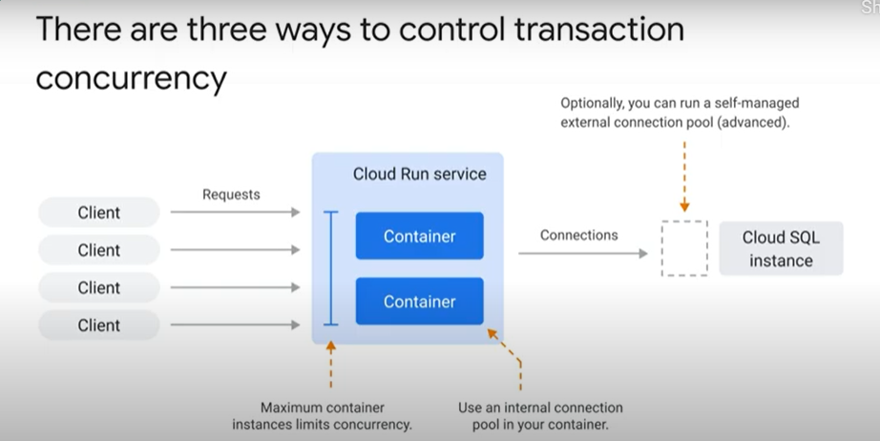
  + 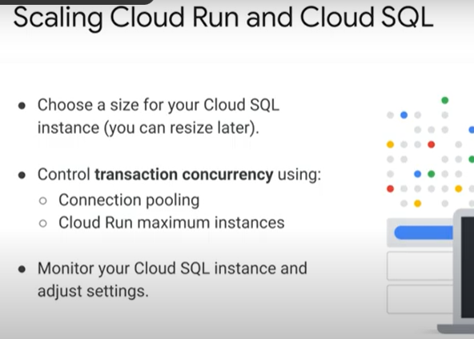
  + 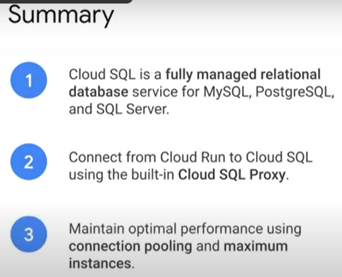
* Connecting to Memorystore 2 minutes - <https://youtu.be/NwHxz_FHyVg>
  + 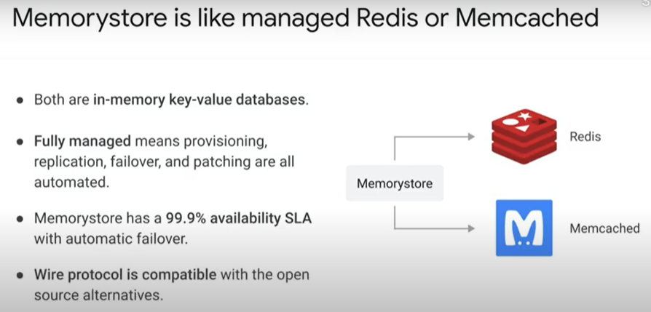
  + 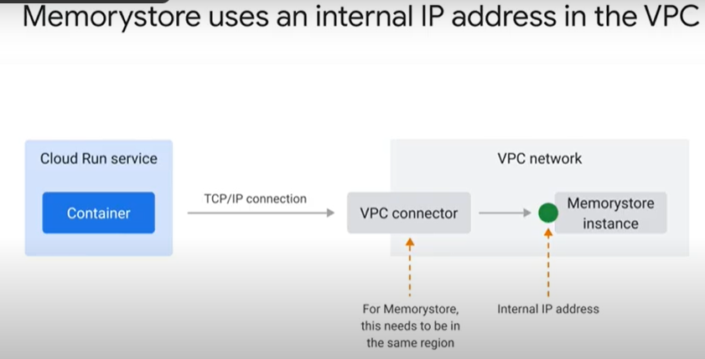
  + 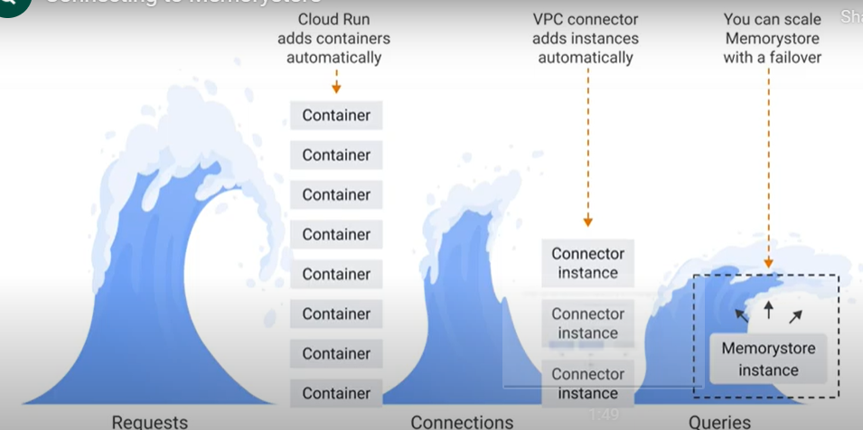
  + 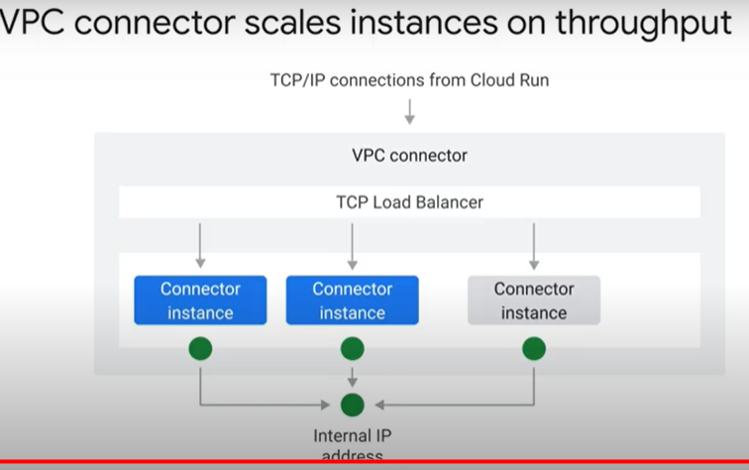
  + 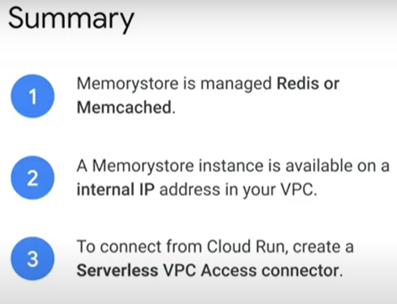
* Cloud Storage, Cloud Spanner, Firestore 2 minutes - <https://youtu.be/X7hMcF-V4x4>
  + 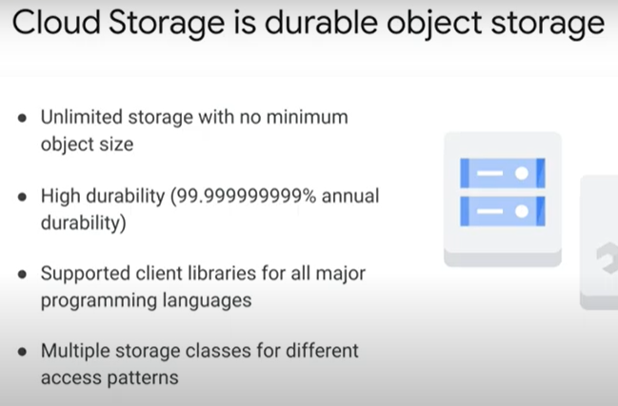
  + 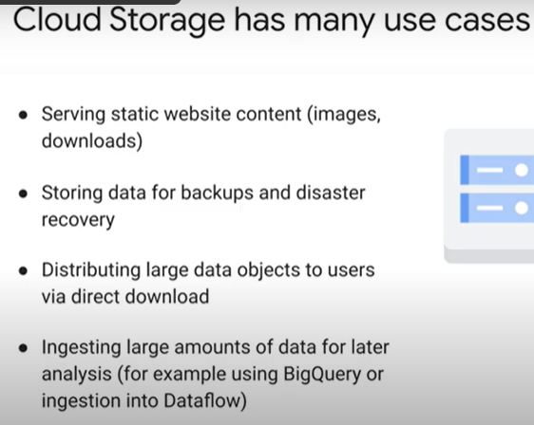
  + 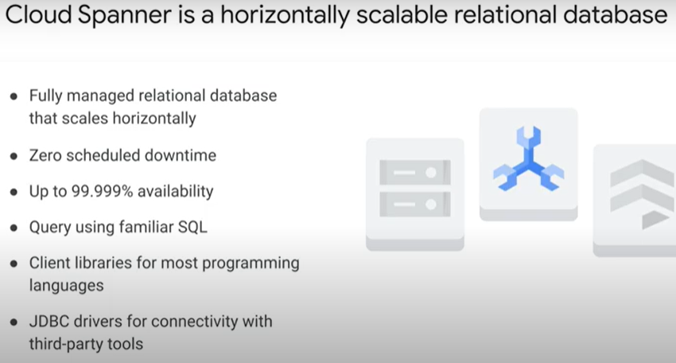
  + 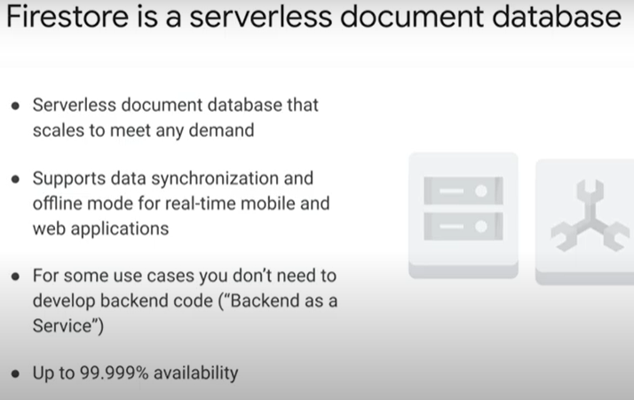
  + 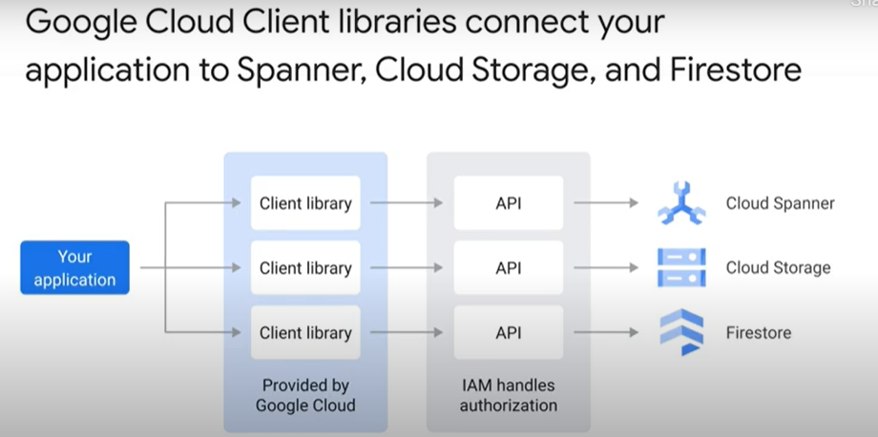
* Multi-region data persistence 1 minute - <https://youtu.be/TjqJjMnoRjc>
  + 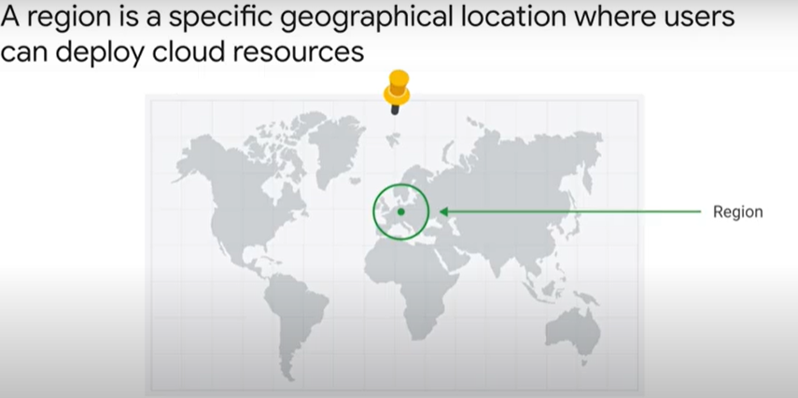
  + 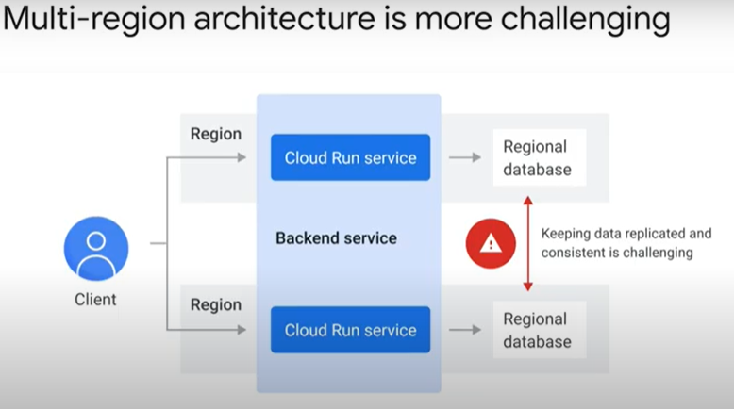
  + 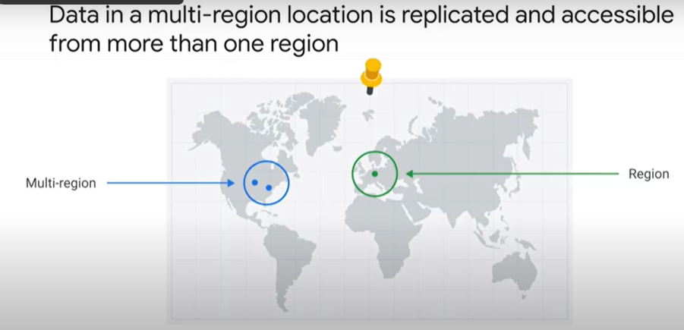
  + 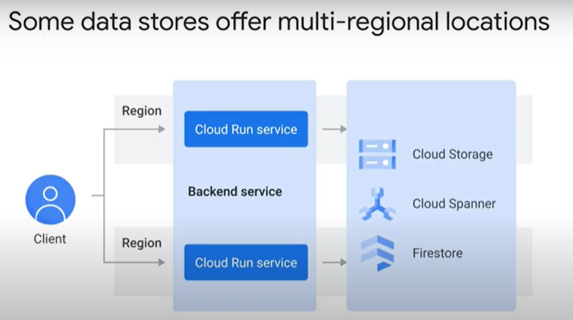
  + 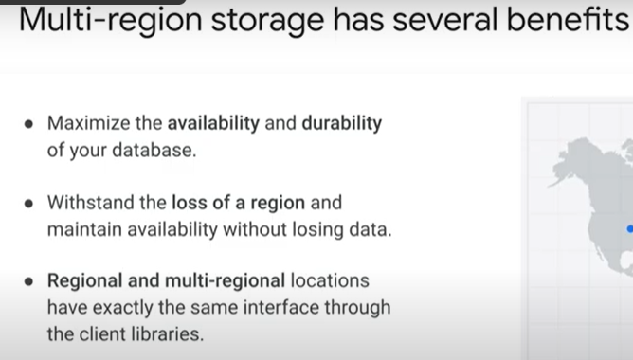

### Cloud SQL with Cloud Run [APPRUN] 45 minutes

* + Objectives
    - Configure the environment and enable the Cloud Run API.
    - Create a Cloud SQL instance.
    - Populate a Cloud SQL instance.
    - Use environment variables for the Cloud Run service.
    - Deploy a public Cloud Run service.
  + Overview
    - Cloud SQL automatically ensures your databases are reliable, secure, and scalable so that your business continues to run without disruption. Cloud SQL automates all your backups, replication, encryption patches, and capacity increases—while ensuring greater than 99.95% availability, anywhere in the world.
    - Lab content is based on resolving a customer use case through the use of serverless infrastructure. The lab features three high level sections that resolve a technical problem:
      * Situational Overview
      * Requirements Gathering
      * Developing a minimal viable product
  + Prerequisites
    - These labs are based on intermediate knowledge of Google Cloud. While the steps required are covered in the content, it would be helpful to have familiarity with any of the following products:
      * Cloud Build
      * Cloud Tasks
      * Cloud Run
      * Cloud SQL
  + Situational Overview
    - Scenario: In this lab, you will help the development team at Critter Junction investigate Cloud SQL. The company runs its infrastructure on Google Cloud and is very interested in experimenting with serverless.
    - The dev team would like to explore how to use Cloud SQL and Cloud Run.
  + Requirements Gathering
    - The team at Critter Junction have a web application that requires a data store. Cloud SQL appears to be a good solution, but the team does not have any experience with this product.
    - The team would also like a solution that does not introduce any additional complexity to their systems. Historically they have used PostgreSQL so would like to use that if it's an option. Now you know a bit more about Critter Junction and the issues they face, try and prioritise the key criteria for a solution.
    - Defining Critter Junction priorities
      * The team at Critter Junction are keen to define a solution that can be implemented quickly. They explain their current event processing as represented by the diagram illustrated below:
      * A series of meetings with stakeholders are held to ascertain the key priorities. The results of which are shown below:

|  |  |
| --- | --- |
| **Ref** | **User Story** |
| 1 | As a development lead, I want to focus on frontend development, so my team can maintain velocity. |
| 2 | As a data lead, I want to focus on existing skill sets, so that developers minimize learning new products. |
| 3 | As an ops lead, I want to ensure service accounts are used, so product authentication is handled internally. |

* + - * From a discussion with the team leads, the following high level tasks are defined:

|  |  |
| --- | --- |
| **Ref** | **Definition of Done** |
| 1 | Deploy the website using Cloud Run |
| 2 | Use Cloud SQL with Postgres |
| 3 | Use a Service Account with Cloud SQL with minimise IAM permissions |

* + - * The following high level architecture diagram summaries the minimal viable product they wish to investigate.
        + 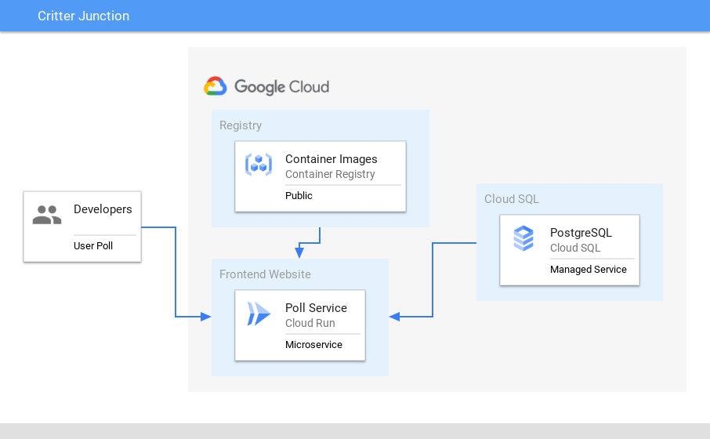
      * In the proposed solution, Cloud SQL will be used to handle the data tier.
  + Developing a minimal viable product (MVP)
    - Critter Junction has a website that they would like to integrate with Cloud SQL. To build an MVP the following activities are required:
      * Configure the environment
      * Create a Cloud SQL instance
      * Use environment variables for the Cloud Run service
      * Deploy a public Cloud Run service
  + Configure the environment
    - gcloud services enable run.googleapis.com
    - gcloud config set compute/region us-central1
    - LOCATION="us-central1"
  + Cloud SQL Overview
    - Google Cloud SQL is a fully managed relational database service for MySQL, PostgreSQL, and SQL Server.
    - Cloud SQL Key Features:

|  |  |
| --- | --- |
| **Feature** | **Description** |
| Fully Managed | Cloud SQL automatically ensures your databases are reliable, secure, and scalable so that your business continues to run without disruption. Cloud SQL automates all your backups, replication, encryption patches, and capacity increases—while ensuring greater than 99.95% availability, anywhere in the world. |
| Integrated | Access Cloud SQL instances from just about any application. Easily connect from [App Engine](https://cloud.google.com/appengine), [Compute Engine](https://cloud.google.com/compute), [Google Kubernetes Engine](https://cloud.google.com/kubernetes-engine), and your workstation. Open up analytics possibilities by using BigQuery to [directly query](https://cloud.google.com/bigquery/docs/cloud-sql-federated-queries) your Cloud SQL databases. |
| Reliable | Easily configure replication and backups to protect your data. Go further by enabling automatic failover to make your database highly available. Your data is automatically encrypted, and Cloud SQL is SSAE 16, ISO 27001, and PCI DSS compliant and supports HIPAA compliance. |
| Easy Migration to Cloud SQL | Database Migration Service (DMS) makes it easy to migrate your production databases to Cloud SQL with minimal downtime. This serverless offering eliminates the manual hassle of provisioning, managing, and monitoring migration-specific resources. DMS leverages the native replication capabilities of MySQL and PostgreSQL to maximize the fidelity and reliability of your migration. And it's available at no additional charge for native like-to-like migrations to Cloud SQL. |

* + - Now you understand what Cloud SQL provides, it is time to configure our project to use it.
  + Create a Cloud SQL instance
    - As you now know Cloud SQL requires a number of configuration options. Learn how to configure a PostgreSQL database in the following section.
    - Create a new Cloud SQL instance and add the following values:
    - Create a PostgreSQL instance with the following values

|  |  |
| --- | --- |
| **Field** | **Value** |
| Instance ID | poll-database |
| Password | secretpassword |
| Database version | PostgreSQL 13 |
| Region | us-central1 |
| Zone | Single Zone |

* + - Click "Create Instance" bca7d471ce243302.png
    - Once the instance has been created a couple of things to note:
    - Cloud SQL uses a connection name which is composed of the project ID + region + database name. A service account is also created to be used to access the database created.
    - Instance connection settings
      * 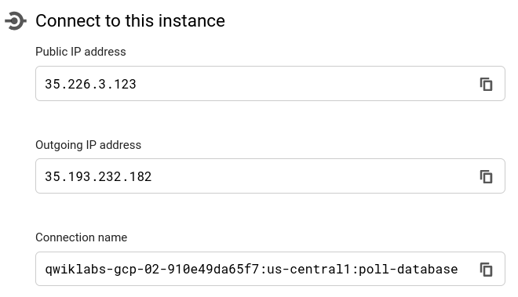
    - Service Account setting
      * 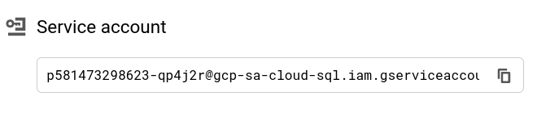
    - Great work. The Cloud SQL database has been created successfully. In the next section populate the database with the required table and data.
  + Populate the Cloud SQL instance
    - As you now know Cloud SQL requires a number of configuration options. Learn how to configure a PostgreSQL database in the following section.
    - Create a new Cloud SQL instance and add the following values:
    - Connect to the Cloud SQL instance (Allowlist will be created for Cloud Shell IP)
      * gcloud sql connect poll-database --user=postgres
    - Enter the Cloud SQL password when requested (i.e. "secretpassword")
    - Connect to the database
      * \connect postgres;
    - Create the votes table
      * CREATE TABLE IF NOT EXISTS votes
      * ( vote_id SERIAL NOT NULL, time_cast timestamp NOT NULL,
      * candidate VARCHAR(6) NOT NULL, PRIMARY KEY (vote_id) );
    - Create the totals table
      * CREATE TABLE IF NOT EXISTS totals
      * ( total_id SERIAL NOT NULL, candidate VARCHAR(6) NOT NULL,
      * num_votes INT DEFAULT 0, PRIMARY KEY (total_id) );
    - Initialise the data for Tabs
      * INSERT INTO totals (candidate, num_votes) VALUES ('TABS', 0);
    - Initialise the data for Spaces
      * INSERT INTO totals (candidate, num_votes) VALUES ('SPACES', 0);
    - The Cloud SQL database has been successfully populated with the data required for the application. In the next section deploy a Cloud Run service to connect to the database.
  + Deploy a public service
    - To provision the tabspaces service the application expects some environment variables to be set.

|  |  |
| --- | --- |
| **Environment Value** | **Description** |
| DB_USER | Name of the database user |
| DB_PASS | Password for the database user |
| DB_NAME | Name of the database |
| CLOUD_SQL_CONNECTION_NAME | The name given to the Cloud SQL instance |

* + - The environment values will be passed to the application and used by the deployed application.
    - Deploy the Poll service on Cloud Run:
      * Set the environment variables for the Cloud SQL connection
        + CLOUD_SQL_CONNECTION_NAME=$(gcloud sql instances describe poll-database --format='value(connectionName)')
      * Deploy poll Cloud RUN service
        + gcloud beta run deploy poll-service \
        + --image gcr.io/qwiklabs-resources/gsp737-tabspaces \
        + --region $LOCATION \
        + --allow-unauthenticated \
        + --add-cloudsql-instances=$CLOUD_SQL_CONNECTION_NAME \
        + --set-env-vars "DB_USER=postgres" \
        + --set-env-vars "DB_PASS=secretpassword" \
        + --set-env-vars "DB_NAME=postgres" \
        + --set-env-vars "CLOUD_SQL_CONNECTION_NAME=$CLOUD_SQL_CONNECTION_NAME"
      * Cloud Run uses key value pairs to define environment variables. Find out more by reading the Cloud Run documentation using Environment Variables
      * The Cloud Run service endpoint can be accessed as per below:
        + POLL_APP_URL=$(gcloud run services describe poll-service --platform managed --region us-central1 --format="value(status.address.url)")
  + Testing the application
    - To test the application browse to the Cloud Run endpoint and enter some data.
    - The Poll service should look similar to below:
      * 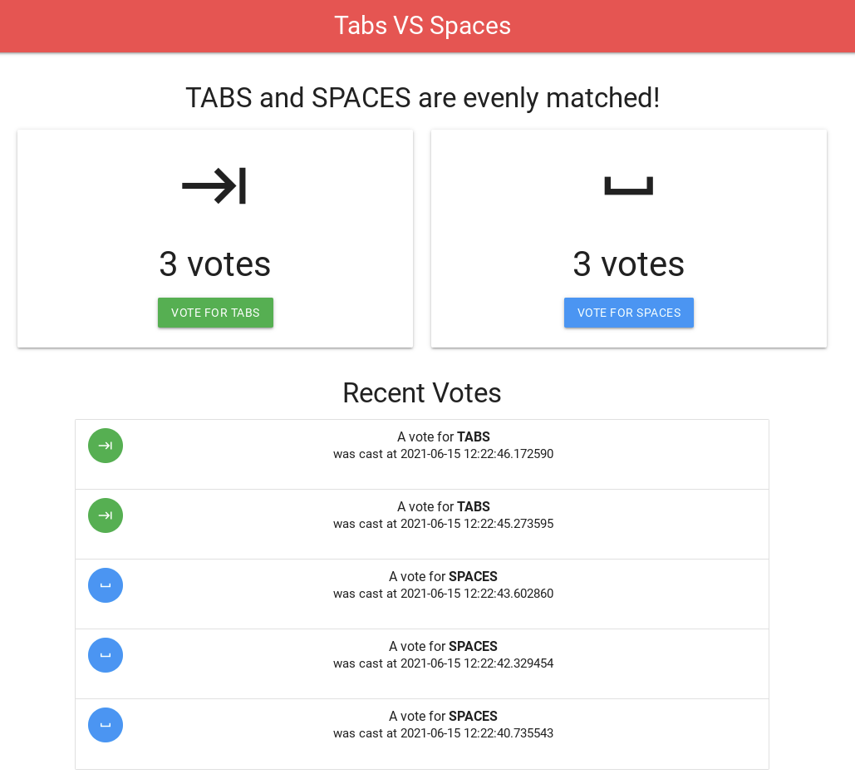
* Quiz
  + What is Cloud Spanner?
    - A horizontally scalable, fully-managed alternative to Cloud SQL
  + Data stores that offer a multi-regional location are (select all that apply):
    - Firestore
    - Cloud Storage
    - Cloud Spanner
  + Cloud Run scales dynamically by adding containers. What is the maximum number of containers Cloud Run can scale up to (unless you request a quota override)?
    - Up to 1,000 containers
  + What is Firestore?
    - A serverless document databaser
  + You must create a Serverless VPC Access Connector if you want to connect to:
    - Memorystore

## 6.9. Service-to-Service Communication

### Request/response 5 minutes- <https://youtu.be/GnzkksPFea0>

* + 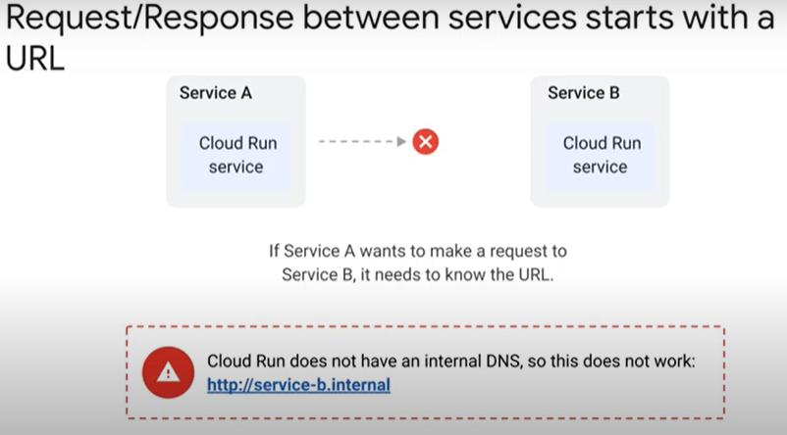
  + 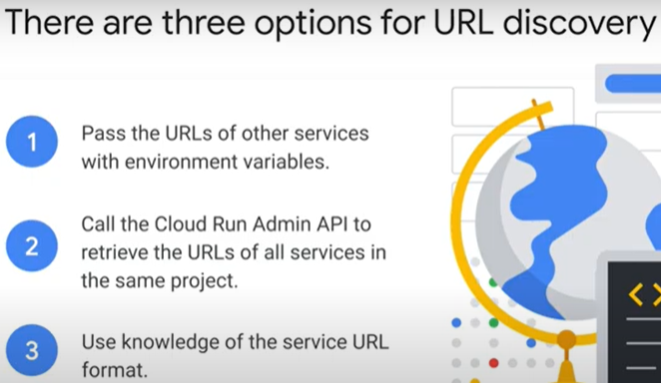 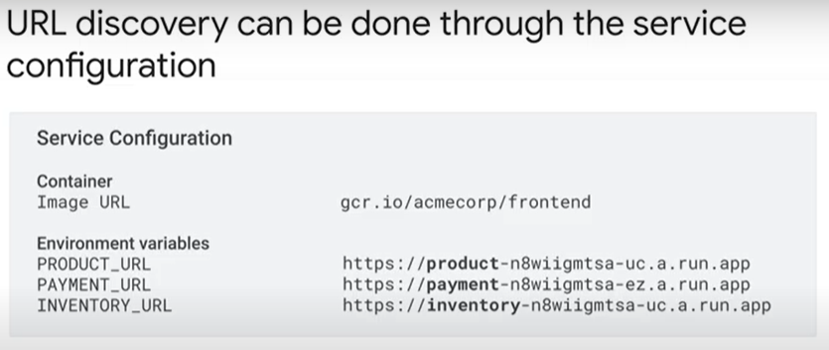
  + 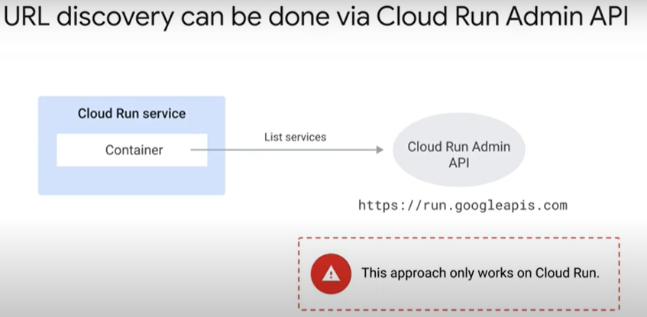 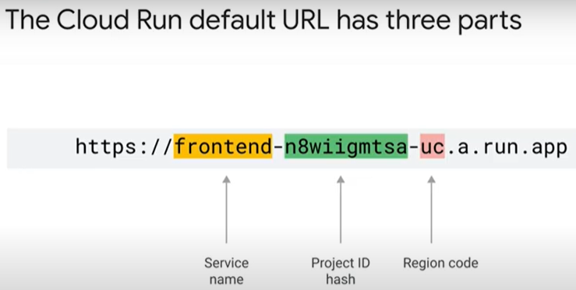
  + 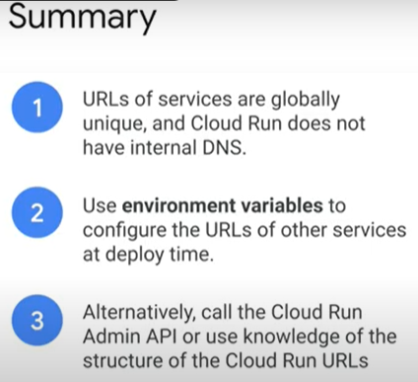
* Pub/Sub 11 minutes - <https://youtu.be/E1MfdNCyjTQ>
  + 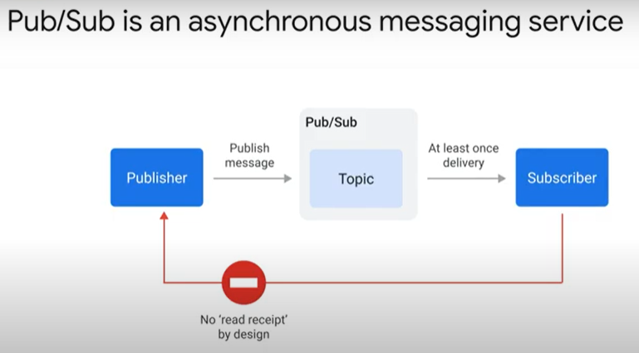 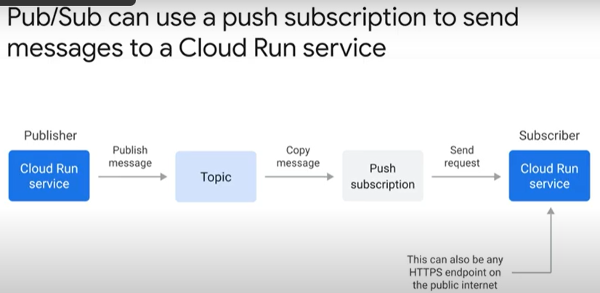
  + 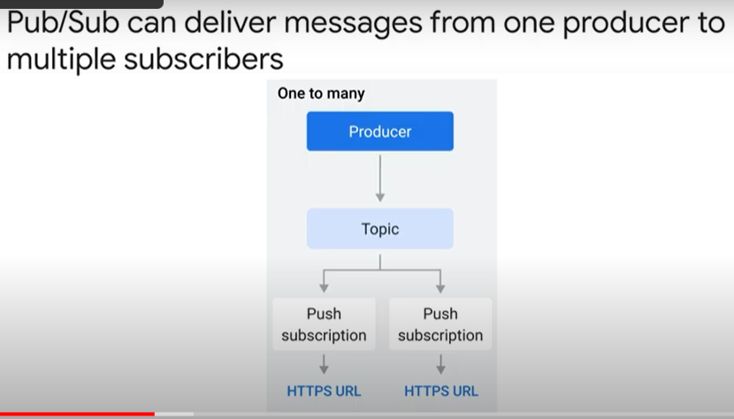 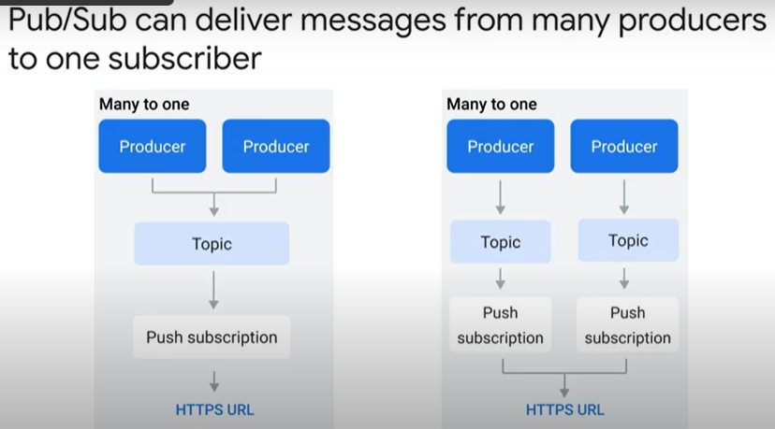
  + 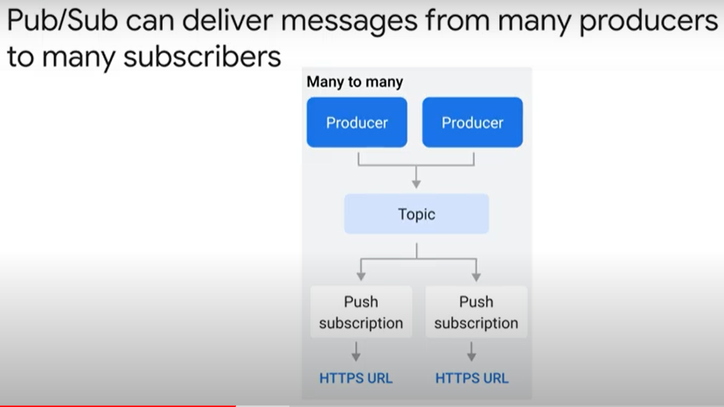 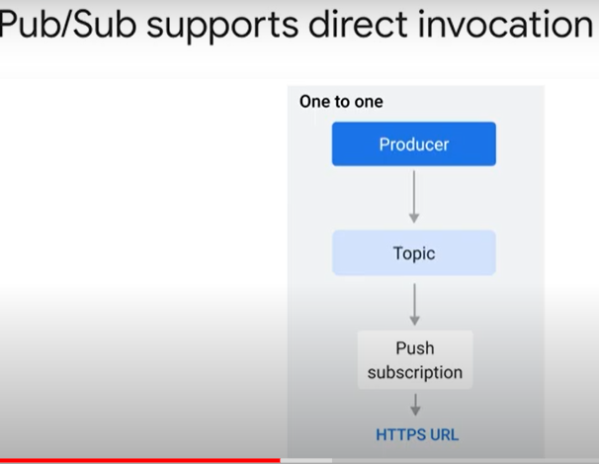
  + 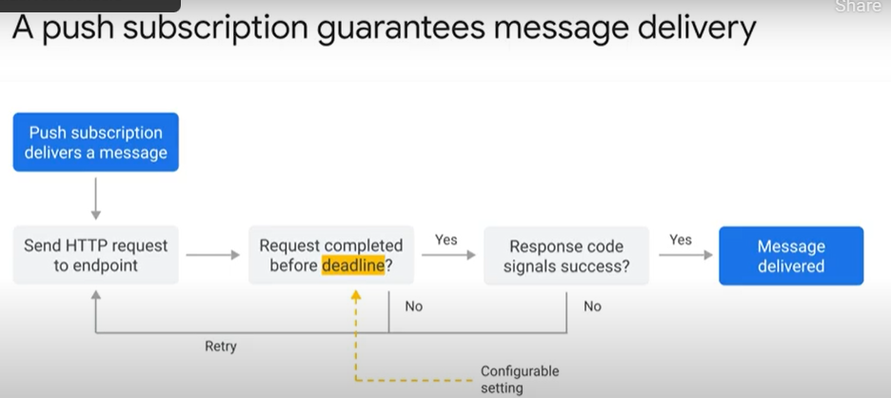
  + 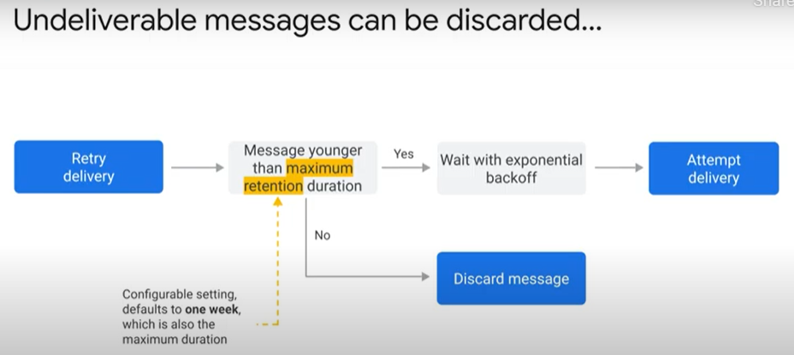
  + 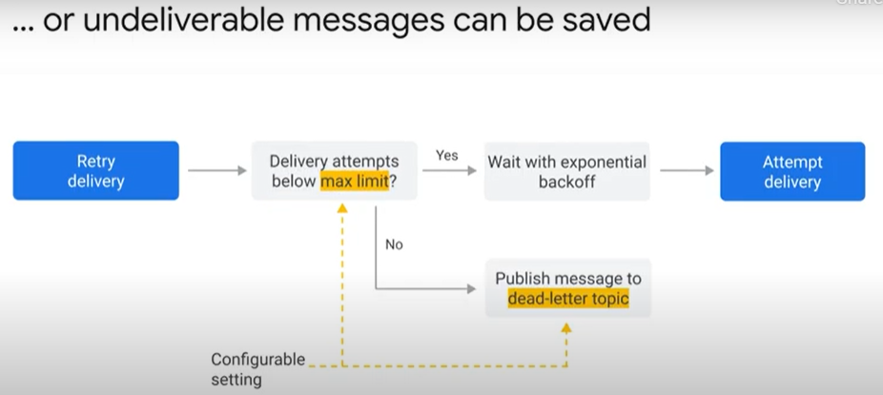
  + 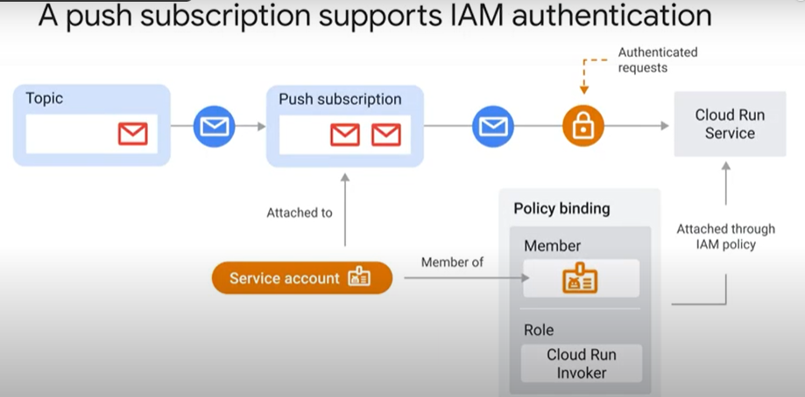
  + 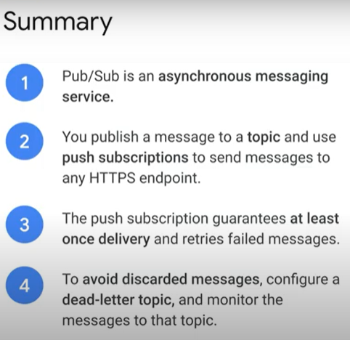 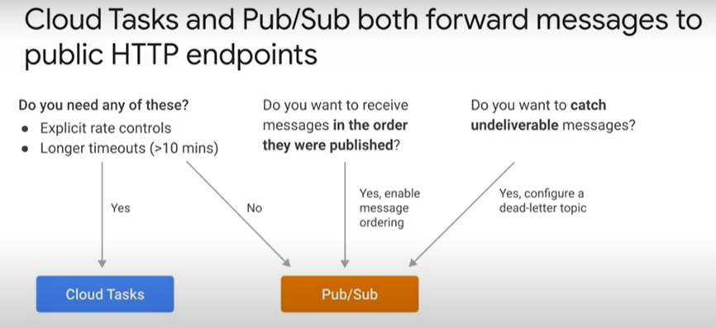
* Handling retries 2 minutes - <https://youtu.be/pJU8RC4qPIQ>
  + 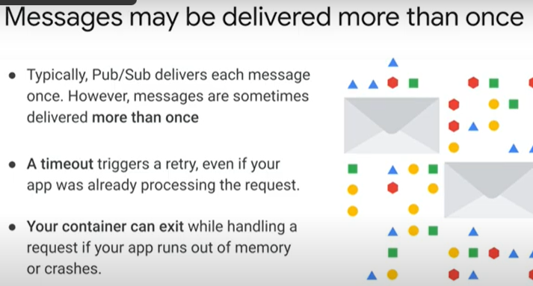
  + 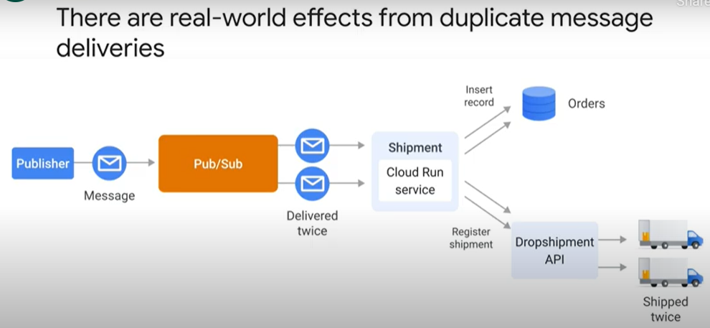
  + 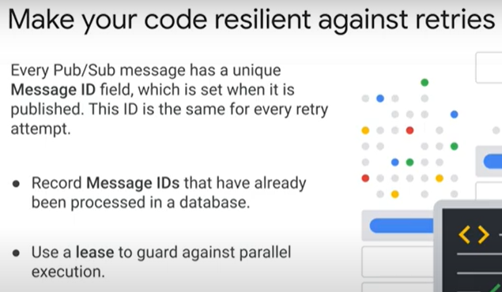
* Receiving events 3 minutes - <https://youtu.be/WftdpX-C4PE>
  + 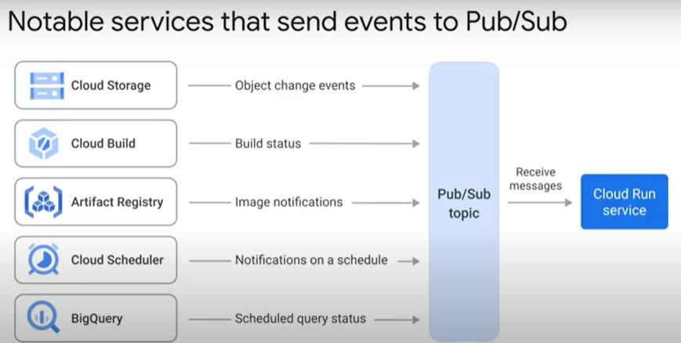
  + 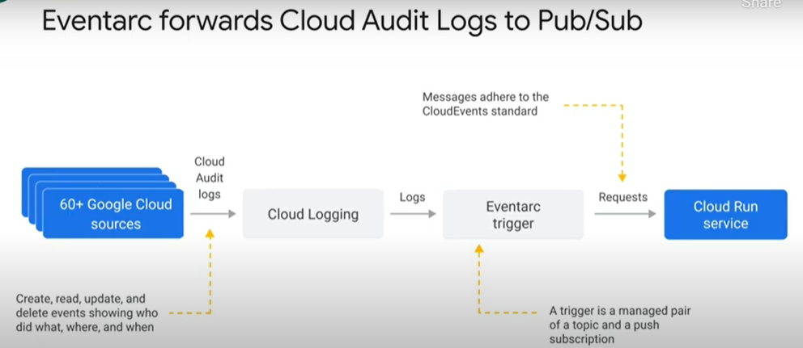
  + 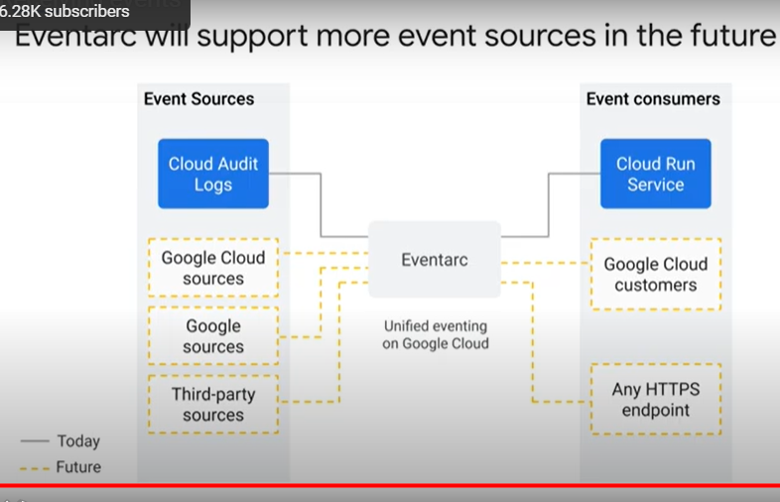
  + 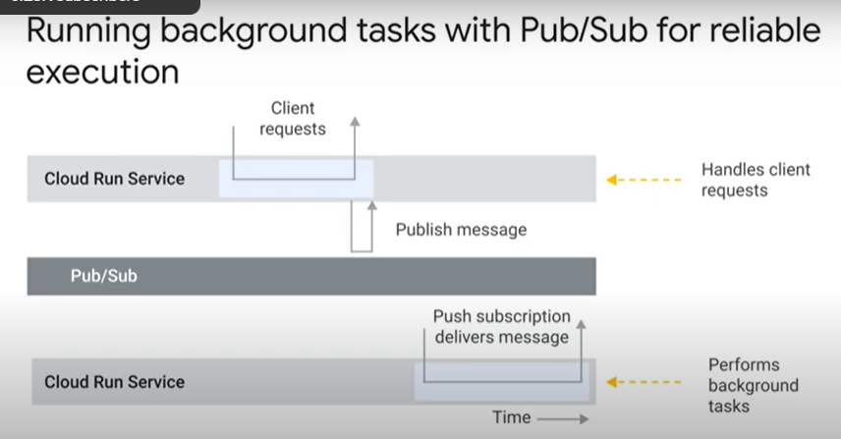
* Background tasks 2 minutes - <https://youtu.be/y_LjIUmYL0Y>
  + 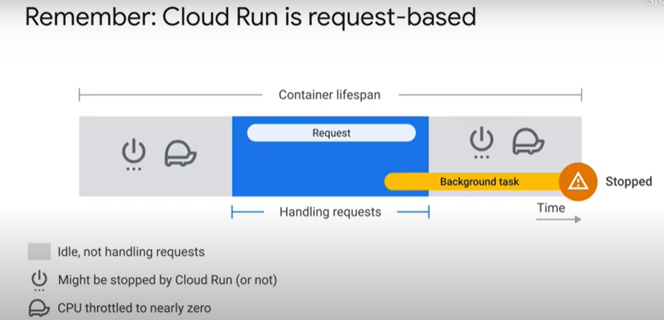
  + 
  + 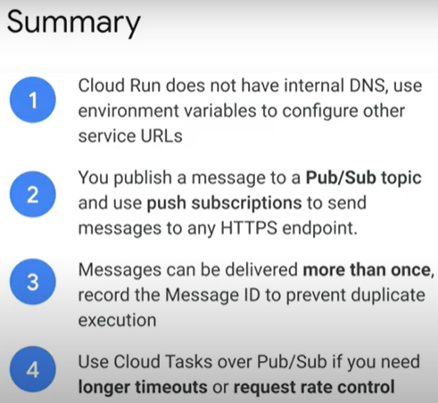

### Using Cloud PubSub with Cloud Run [APPRUN] 45 minutes

* + Objectives
    - Enable the Cloud Run API.
    - Deploy a Cloud Run service.
    - Deploy a Pub/Sub service.
    - Create a Pub/sub subscription.
  + Overview
    - Cloud PubSub enables applications to take advantage of efficient message queues. The service is compatible with a range of services and in this lab, learn how to it with Cloud Run.
    - Lab content is based on resolving a customer use case through the use of serverless infrastructure. The lab features three high level sections that resolve a technical problem:
      * Situational Overview
      * Requirements Gathering
      * Developing a minimal viable product
  + Prerequisites
    - Cloud Pub/Sub
    - Cloud Build
    - Cloud Run
  + Situational Overview
    - In this lab, you will help the development team at Critter Junction investigate Cloud PubSub. The team would like to explore how to perform efficient queue processing within their applications.
  + Requirements Gathering
    - The team at Critter Junction have a public web application and several microservices built on Google Cloud. Communication between the microservices is critical and needs a resilient form of messaging to be established between each application component.
    - The dev team's previous attempts were unsuccessful due to the microservices needing to know a lot about each other ( i.e. High Coupling). In addition, if a service was temporarily unavailable, messages would be lost.
    - The team need a solution that includes a level of resilience without introducing additional service dependencies (i.e. Low Coupling) into their systems. Now that you know a bit more about Critter Junction and the issues they face, try and prioritise the key criteria for a solution.
    - Defining Critter Junction priorities
      * Initial discussions with the Critter Junction stakeholders to ascertain the key priorities are held. The results of which are shown below:

|  |  |
| --- | --- |
| **Ref** | **User Story** |
| 1 | As a developer lead, I want to ensure messaging is resilient, so service operations will be restored without needing manual intervention. |
| 2 | As a program manager I want services to be capable of scaling seamlessly, so additional transactional load does not lead to system instability. |
| 3 | As an ops lead, I want services to be managed, so I don't need to reassign staff from important maintenance work. |

* + - * From a discussion with the team leads, the following high level tasks are defined:

|  |  |
| --- | --- |
| **Ref** | **Definition of Done** |
| 1 | Establish an asynchronous component for inter-service communication |
| 2 | Implement proven the scalability of the solution |
| 3 | Services must run unsupervised |

* + - * The team at Critter Junction are keen to define a solution that can be implemented quickly. In consideration of the requirements, the dev team narrows their options down to two:
        + Cloud Pub/Sub
        + Cloud Tasks
    - Cloud Pub/Sub versus Cloud Tasks

|  |  |  |
| --- | --- | --- |
| **Product** | **Use case** | **Choice** |
| ***Cloud Pub/Sub*** | ***"Optimal for more general event data ingestion and distribution patterns where some degree of control over execution can be sacrificed."*** |  |
| Cloud Tasks | "Appropriate for use cases where a task producer needs to defer or control the execution |  |

* + - * Consideration of the requirements by the dev team leads them to choose Cloud Pub/Sub because they only require a push based distribution pattern. The following high level architecture diagram summarizes the minimal viable product (MVP) they wish to investigate.
        + 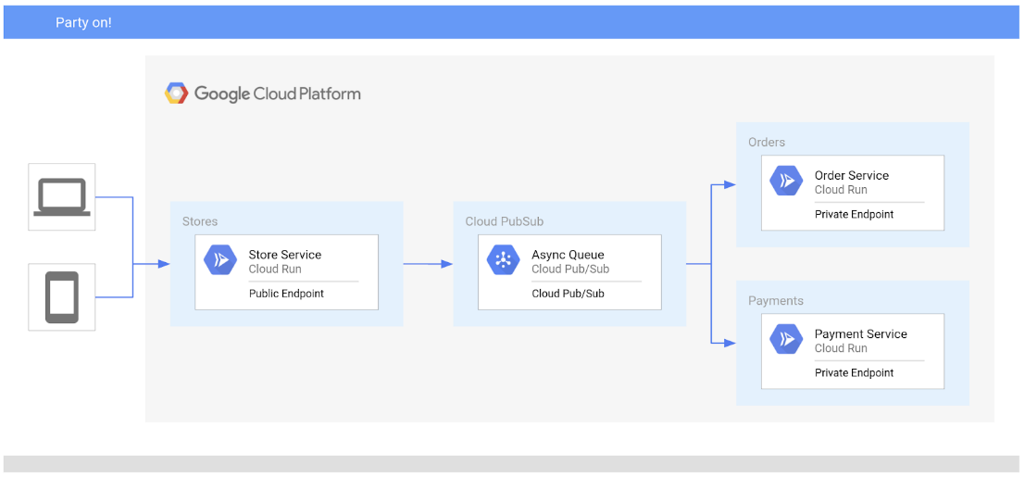
      * In the proposed solution, Cloud Pub/Sub will be used to handle asynchronous messages between services.
  + Ensure that the Cloud Pub/Sub API is successfully enabled
    - To ensure access to the necessary API, restart the connection to the Cloud Pub/Sub API.
    - In the Cloud Console, enter "Cloud Pub/Sub API" in the top search bar. Click on the result for Cloud Pub/Sub API.
    - Click Manage. Click Disable API. If asked to confirm, click Disable.
    - Again, when prompted Do you want to disable Cloud Pub/Sub API and its dependent APIs?, Click Confirm.
    - Click Enable.
    - When the API has been enabled again, the page will show the option to disable. Disable_API.png
  + Developing a minimal viable product (MVP)
    - Critter Junction have multiple Cloud Run services that they would like integrated with Cloud Pub/Sub. To build an MVP, the following tasks are required:
      * Deploy a producer service
      * Deploy a consumer service
      * Create a service account
      * Create a Cloud Pub/Sub queue
    - Deploy a producer service
      * Critter Junction specifies that the externally facing store service should be configured as a public endpoint, meaning:

|  |  |  |
| --- | --- | --- |
| **Type** | **Permission** | **Description** |
| URL Access | --allow-unauthenticated | Make the service PUBLIC (i.e. Unauthenticated users can see it). |
| Invoke Permission | allUsers | Allow the service be invoked/triggered by anyone. |

* + - * The producer store service accepts all the internet based connections for orders. To do this the service is defined as not requiring authentication and can be triggered by anyone.
      * Information collected by this service will be passed to the backend consumer services.
      * Configure and deploy the store service on Cloud Run:
      * Enable Cloud Run API, set the region and location
        + gcloud services enable run.googleapis.com
        + gcloud config set compute/region us-central1
        + LOCATION="us-central1"
      * Deploy the store service
        + gcloud run deploy store-service \
        + --image gcr.io/qwiklabs-resources/gsp724-store-service \
        + --region $LOCATION \
        + --allow-unauthenticated
      * Once the store service is deployed, the store service is publicly accessible over the internet.
    - Deploy a consumer service
      * The dev team also needs to configure the order service as a private endpoint. Unlike the store service, the order service is not meant to be publicly accessible over the internet and should be provisioned with least privilege permissions. For Cloud Run based services, this can be achieved by using the following settings:

|  |  |  |
| --- | --- | --- |
| **Type** | **Permission** | **Description** |
| URL Access | --no-allow-unauthenticated | Make the service PRIVATE (i.e. Only authenticated users can see it). |
| Invoke Permission | none | Do not allow the service to be invoked/triggered by anyone. |

* + - * Configure and deploy the order service:
      * Deploy the order service
        + gcloud run deploy order-service \
        + --image gcr.io/qwiklabs-resources/gsp724-order-service \
        + --region $LOCATION \
        + --no-allow-unauthenticated
      * Now only authenticated accounts can see the service. In addition, the order service can only be used by an account with a "Cloud Run Invoker" role.
  + Cloud Pub/Sub Overview
    - Google Cloud Pub/Sub is an asynchronous messaging service that decouples services that produce events from services that process events.
    - Cloud Pub/Sub core concepts:
      * Topic
      * Subscription
      * Message
      * Message attribute
    - Cloud Pub/Sub requires a couple of options to be completed prior to successful deployment. In the Cloud Console, Cloud Pub/Sub can be accessed under the Big Data menu option.

|  |  |
| --- | --- |
| **Field** | **Description** |
| Topic | A named resource to which messages are sent by publishers. |
| Subscription | A named resource representing the stream of messages from a single, specific topic, to be delivered to the subscribing application. For more details about subscriptions and message delivery semantics, see the [Subscriber Guide](https://cloud.google.com/pubsub/subscriber). |
| Message | The combination of data and (optional) attributes that a publisher sends to a topic and is eventually delivered to subscribers. |
| Message attribute | A key-value pair that a publisher can define for a message. For example, key **iana.org/language_tag** and value **en** could be added to messages to mark them as readable by an English-speaking subscriber. |

* + - Cloud Pub/Sub can be used in a wide variety of use cases, the most common of which are listed below:

|  |  |
| --- | --- |
| **Use Case** | **Example** |
| Balancing workloads in network clusters | For example, a large queue of tasks can be efficiently distributed among multiple workers, such as Google Compute Engine instances. |
| Implementing asynchronous workflows | For example, an order processing application can place an order on a topic, from which it can be processed by one or more workers. |
| Distributing event notifications | For example, a service that accepts user signups can send notifications whenever a new user registers, and downstream services can subscribe to receive notifications of the event. |
| Refreshing distributed caches | For example, an application can publish invalidation events to update the IDs of objects that have changed. |
| Logging to multiple systems | For example, a Google Compute Engine instance can write logs to the monitoring system, to a database for later querying, and so on. |
| Data streaming from various processes or devices | For example, a residential sensor can stream data to backend servers hosted in the cloud. |
| Reliability improvement | For example, a single-zone Compute Engine service can operate in additional zones by subscribing to a common topic, to recover from failures in a zone or region. |

* + Deploying Cloud Pub/Sub
    - Now that the producer (i.e. store service) and consumer (i.e. order service) services have been successfully deployed. Focus on the main features of Cloud Pub/Sub. Using Cloud Pub/Sub requires two activities:
      * Creating a Topic
      * Creating a Subscription
    - Creating a TOPIC
      * When an asynchronous (push) event is created, the application will be able to process the associated messages. Using Push event processing with Cloud Pub/Sub provides a scalable way to handle messaging on Google Cloud.
      * Create a new Cloud Pub/Sub Topic with the following values:

|  |  |
| --- | --- |
| **Field** | **Value** |
| Name | ORDER_PLACED |
| Encryption | Google-managed key |

* + - * Messages sent via Cloud Pub/Sub are encoded as base64 on transmission and need to be decoded on receipt.
      * Create a Topic in Cloud Pub/Sub
        + gcloud pubsub topics create ORDER_PLACED
      * By creating the Cloud Pub/Sub Topic, messages can now be independently stored in a resilient manner.
  + Creating a Service Account
    - When a subscription event is triggered a service account is needed to invoke the order service. To enable the service account to perform this task the following activities are required:
      * Service Account Creation
      * Bind the Invoker Role Permissions
      * Create the Cloud Pub/Sub Subscription
    - Service Account Creation
      * Create a new Service Account that will provide authenticated access.
      * Create a new Service Account called "Order Initiator":
        + gcloud iam service-accounts create pubsub-cloud-run-invoker --display-name "Order Initiator"
      * Confirm the service account has been created
        + gcloud iam service-accounts list --filter="Order Initiator"
      * At this point the Order Initiator service account is available. However, it does not have a role or permissions assigned. To assign it security permissions, you need to explicitly apply/bind role permissions.
    - Bind the Role Permissions
      * To bind permissions on Cloud Run, you need to know :

|  |  |
| --- | --- |
| **Category** | **Description** |
| Service Name | The name of the deployed service to be accessed |
| Member | The account to bestow the role permission |
| Region | The region in which the service is deployed |
| Platform | The platform type (e.g. Cloud Run Managed, Cloud Run for Anthos, or Cloud Run for VMWare) |

* + - * Next you will bind the service account with the role invoker for the order-service.
      * Bind the service account to the order service:
        + gcloud run services add-iam-policy-binding order-service \
        + --member=serviceAccount:pubsub-cloud-run-invoker@$GOOGLE_CLOUD_PROJECT.iam.gserviceaccount.com \
        + --role=roles/run.invoker --platform managed
      * Add the project number to an environment variable:
        + PROJECT_NUMBER=$(gcloud projects list \
        + --filter="qwiklabs-gcp" \
        + --format='value(PROJECT_NUMBER)')
      * Enable the project service account to create Tokens:
        + gcloud projects add-iam-policy-binding $GOOGLE_CLOUD_PROJECT \
        + --member=serviceAccount:service-$PROJECT_NUMBER@gcp-sa-pubsub.iam.gserviceaccount.com \
        + --role=roles/iam.serviceAccountTokenCreator
  + Creating a Cloud Pub/Sub Subscription
    - Now configure the Cloud Pub/Sub subscription to use the new service account.
    - Add the store service endpoint to an environment variable:
      * ORDER_SERVICE_URL=$(gcloud run services describe order-service \
      * --region $LOCATION \
      * --format="value(status.address.url)")
    - Create a subscription bound to the store service:
      * gcloud pubsub subscriptions create order-service-sub \
      * --topic ORDER_PLACED \
      * --push-endpoint=$ORDER_SERVICE_URL \
      * --push-auth-service-account=pubsub-cloud-run-invoker@$GOOGLE_CLOUD_PROJECT.iam.gserviceaccount.com
    - The new service account has now been given permission to invoke a Cloud Run instance.
  + Testing the application
    - To test the application, send a sample schema to the store service.
    - Create a file called test.json then add the following content:
      * {
      * "billing_address": {
      * "name": "Kylie Scull",
      * "address": "6471 Front Street",
      * "city": "Mountain View",
      * "state_province": "CA",
      * "postal_code": "94043",
      * "country": "US"
      * },
      * "shipping_address": {
      * "name": "Kylie Scull",
      * "address": "9902 Cambridge Grove",
      * "city": "Martinville",
      * "state_province": "BC",
      * "postal_code": "V1A",
      * "country": "Canada"
      * },
      * "items": [
      * {
      * "id": "RW134",
      * "quantity": 1,
      * "sub-total": 12.95
      * },
      * {
      * "id": "IB541",
      * "quantity": 2,
      * "sub-total": 24.5
      * }
      * ]
      * }
    - Add the store service endpoint to an environment variable:
      * STORE_SERVICE_URL=$(gcloud run services describe store-service \
      * --region $LOCATION \
      * --format="value(status.address.url)")
    - Post a message to the store service:
      * curl -X POST -H "Content-Type: application/json" -d @test.json $STORE_SERVICE_URL
    - Store Service
      * The order service (public endpoint) uses Cloud Pub/Sub to transmit information to the store service (private endpoint) to the order service (private endpoint).
      * Post a message to the order service to test communication between the microserices and generate an order ID.
      * Navigation menu > Cloud Run. Check the store service logs to see the order ID generated
      * Add the log filter ORDER ID to see the generated ID by the order service.
        + 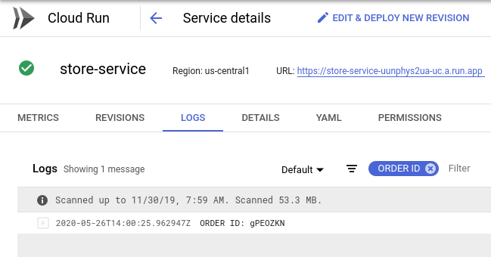
    - Order Service
      * The order service will receive a message from the store service passed via Cloud Pub/Sub. To read the message, the payload needs to be decoded from base64.
      * Check the order service logs to confirm the data schema was successfully transferred.
      * Add the log filter Order Placed to see the generated ID passed to the store service.
        + 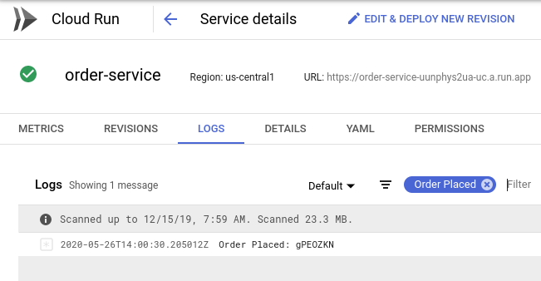
  + Revised architecture
    - Critter Junction have now updated their solution to take advantage of Cloud Pub/Sub. The following high level architecture diagram summaries the solution deployed.
    - 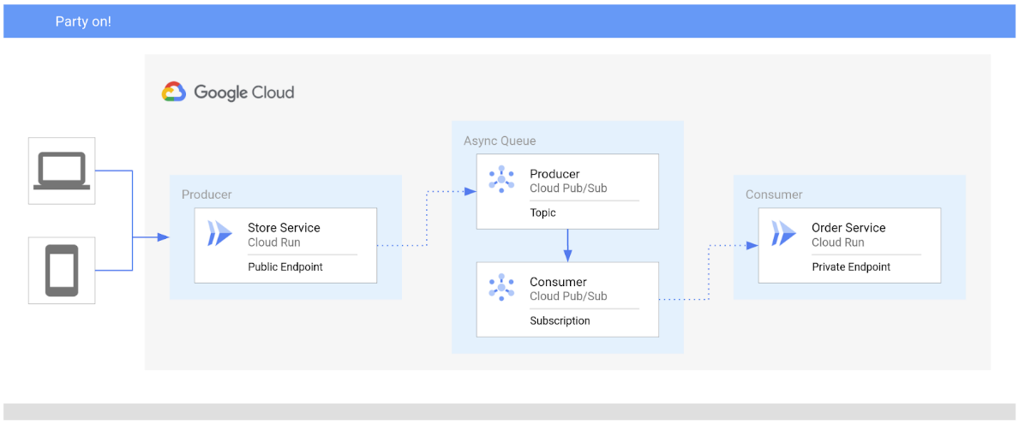
  + You have successfully deployed Cloud Pub/Sub on Google Cloud to asynchronously communicate between Cloud Run services.
* Quiz
  + Select the preferred way to implement URL discovery on Cloud Run:
    - Treat other service URLs as configuration and pass them using environment variables
  + Which statements about Pub/Sub are true? (select all that apply)
    - If you enable message ordering, you can’t catch undeliverable messages
    - A push subscription guarantees at least once delivery to any HTTPS endpoint
    - Messages can be delivered multiple times and out of order
  + Choose Cloud Tasks over Pub/Sub if you: (select all that apply)
    - Require a request timeout longer than 10 minutes up to 30 minutes
    - Need explicit request rate controls

## 6.10. Building Serverless Workflows

* Example workflows 1 minute - <https://youtu.be/WIIx81EBHko>
  + 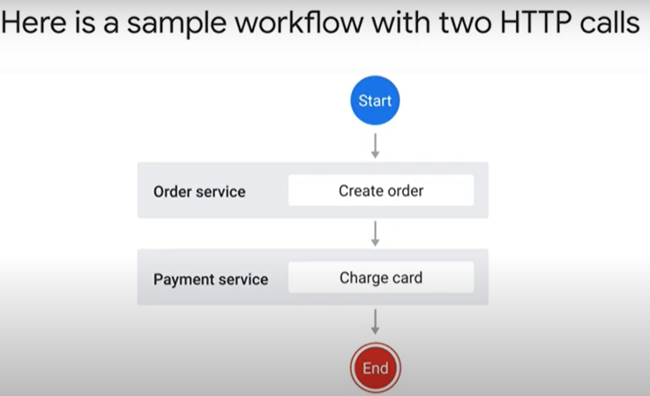 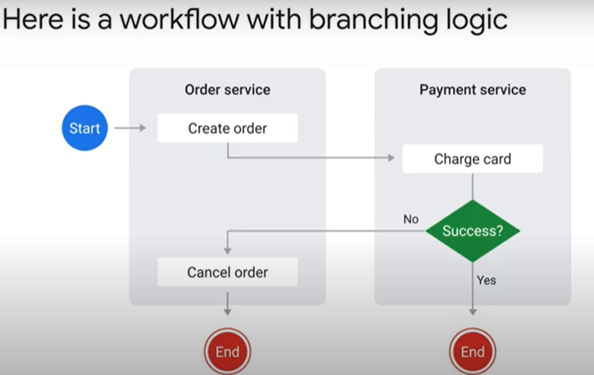
  + 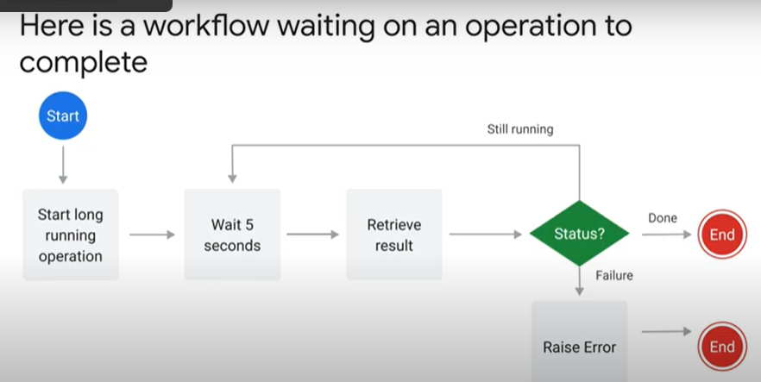 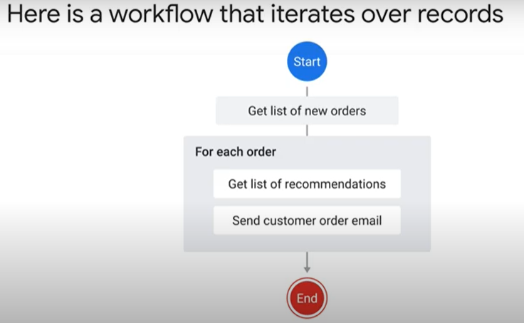
* Workflow development 2 minutes - <https://youtu.be/-t1dwLPXLlY>
  + 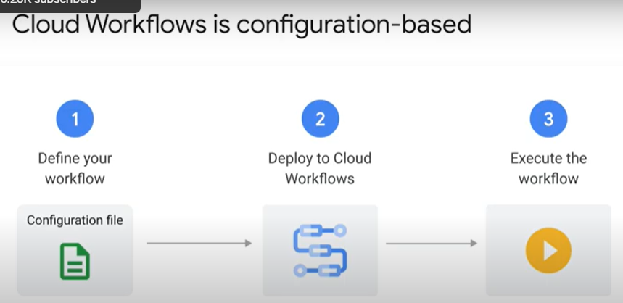 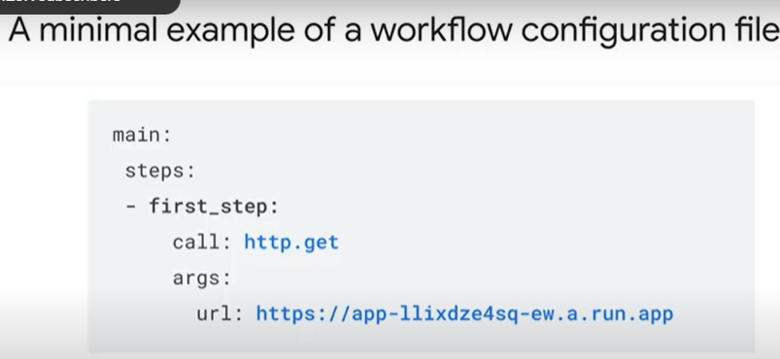
  + 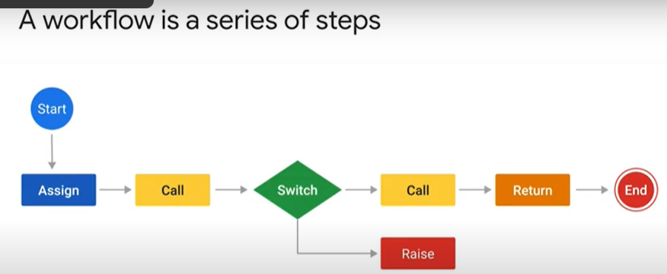 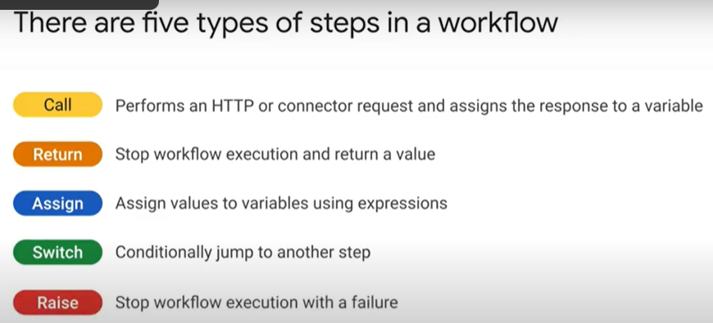
  + 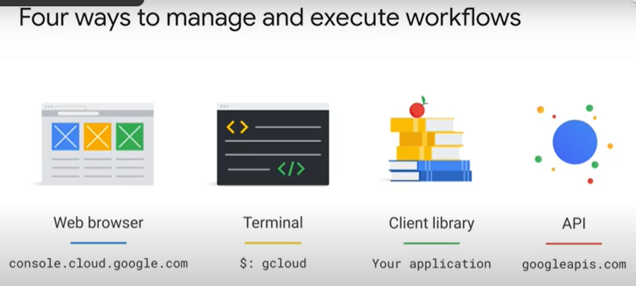 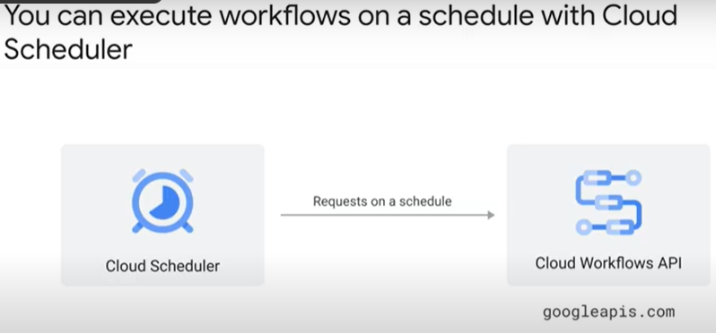
* Calls and return 4 minutes - <https://youtu.be/BvcOLR-96Ds>
  + 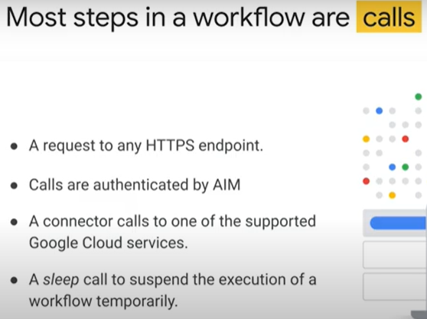 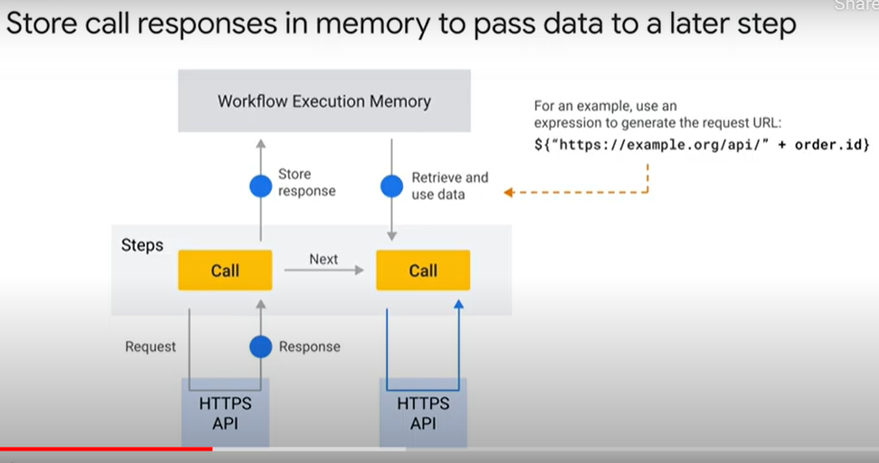
  + 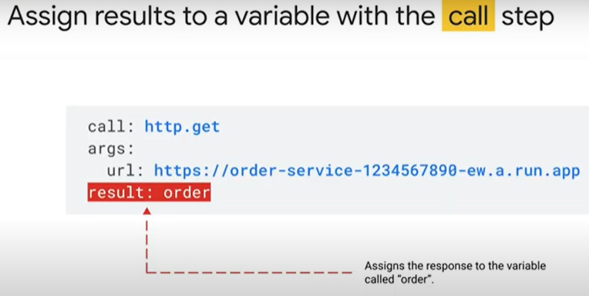 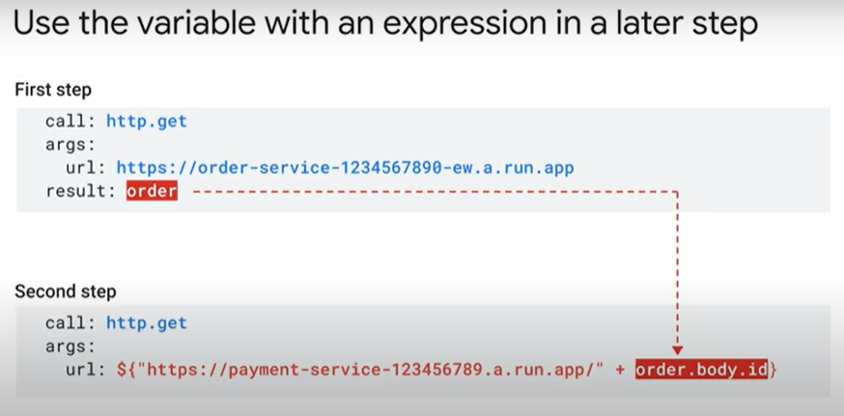
  + 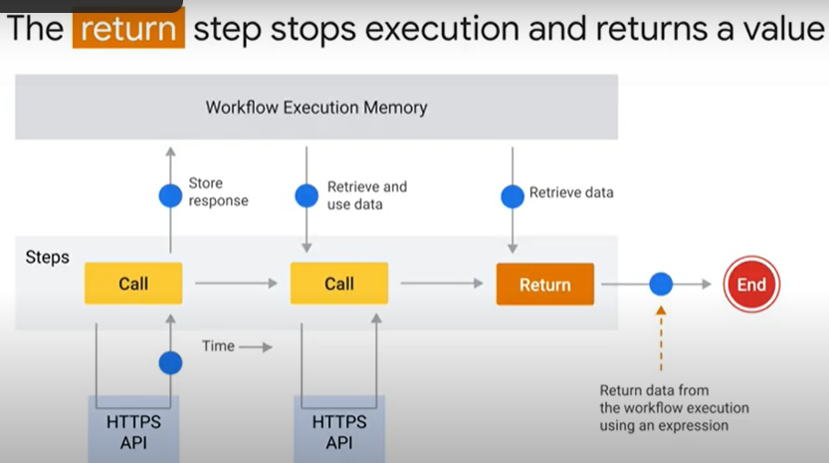 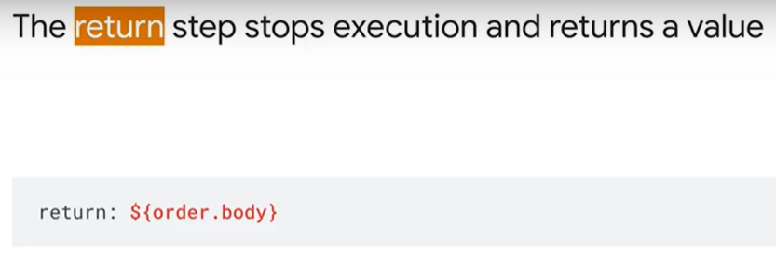
  + 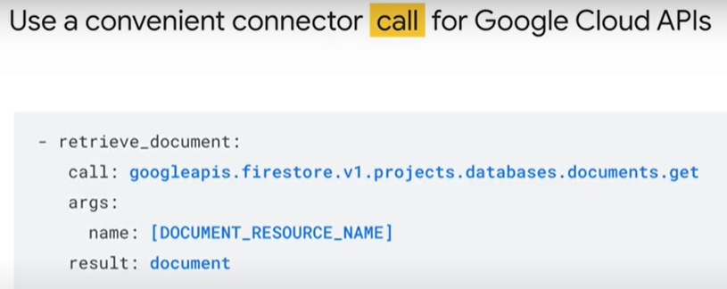 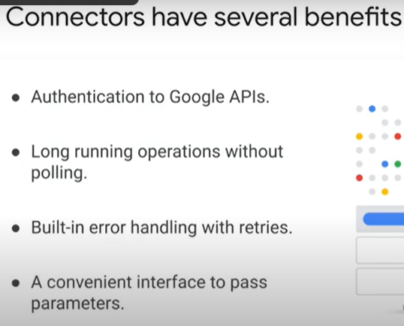
  + 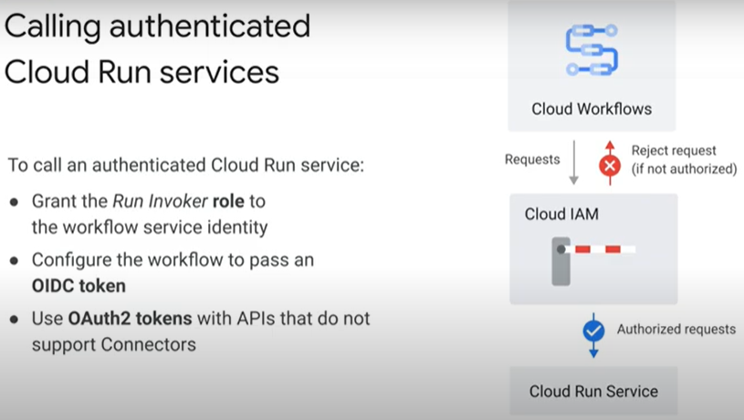 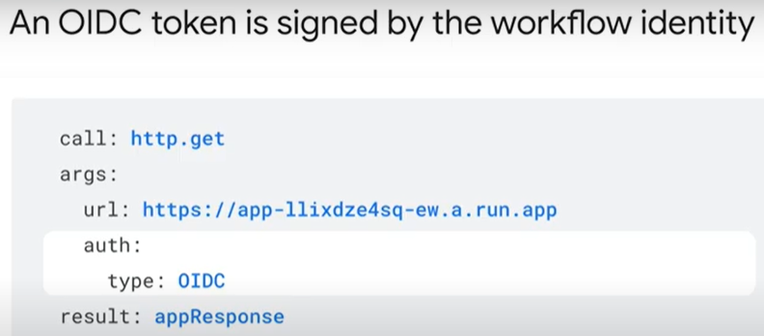
  + 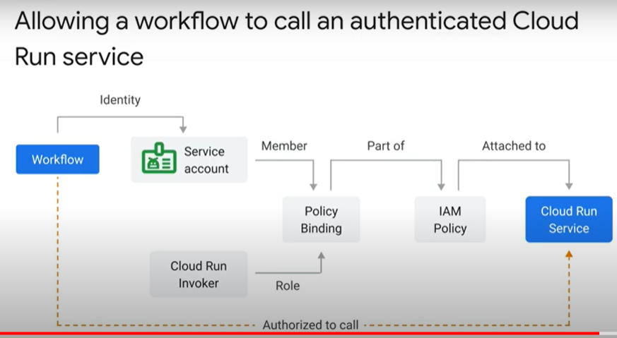 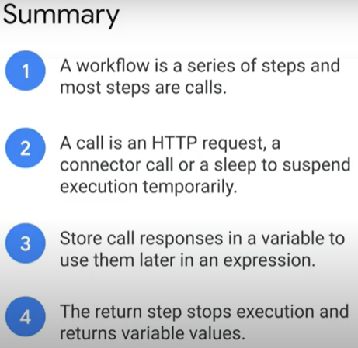
* Expressions 1 minute - <https://youtu.be/IN3qn6JABEw>
  + 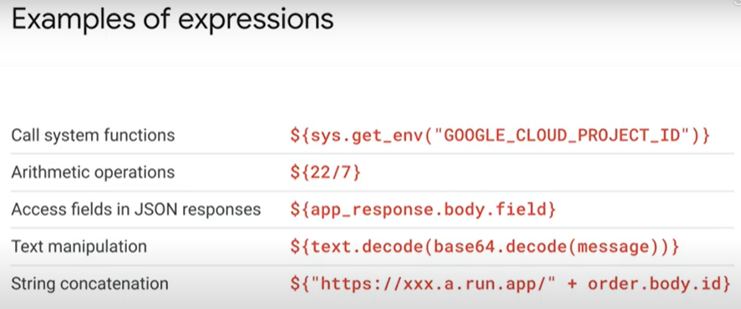
  + 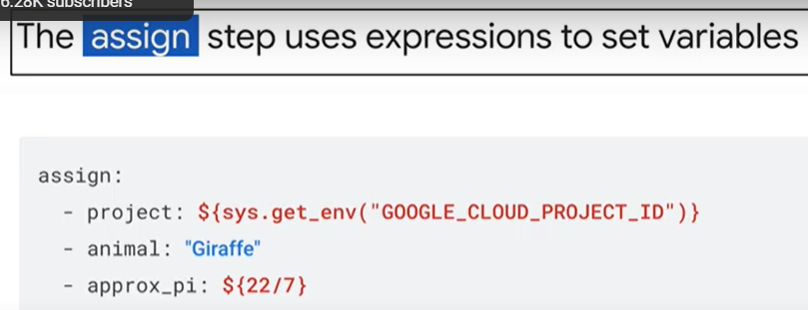 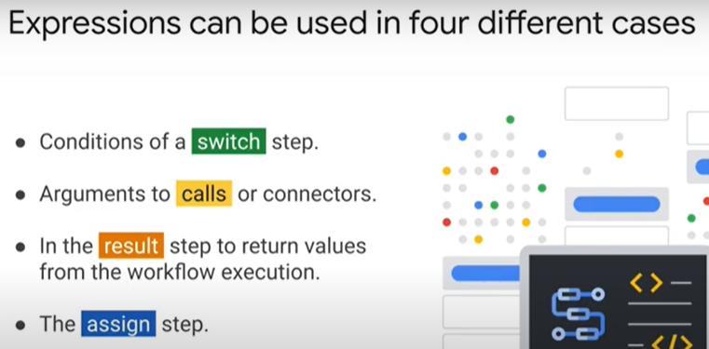
* Using retries 1 minute - <https://youtu.be/bYWp7v8b2cs>
  + 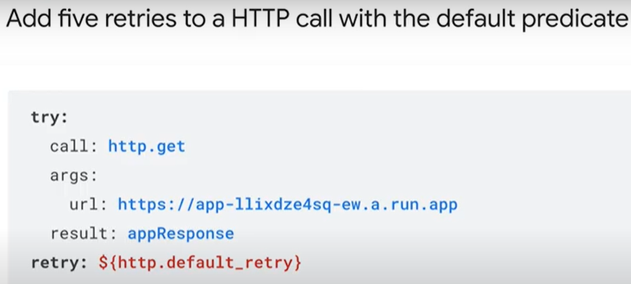 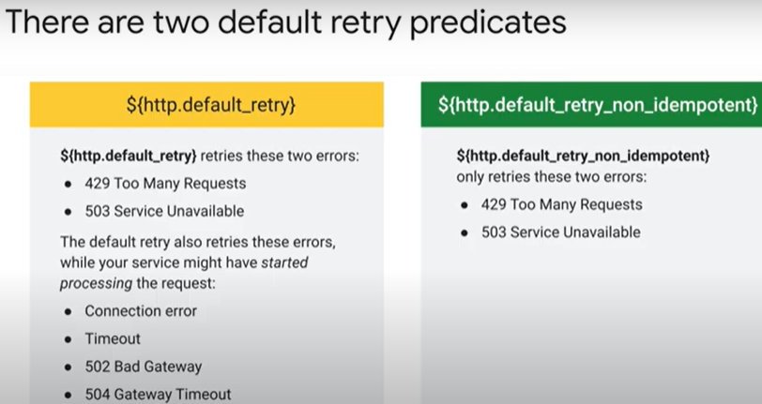
* Switch and raise 1 minute - <https://youtu.be/AmEiC_Dypck>
  + 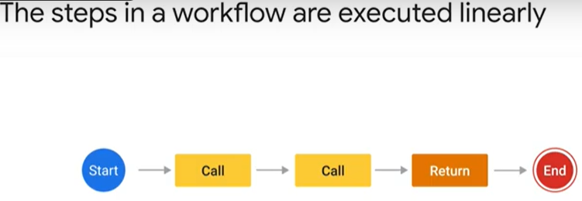 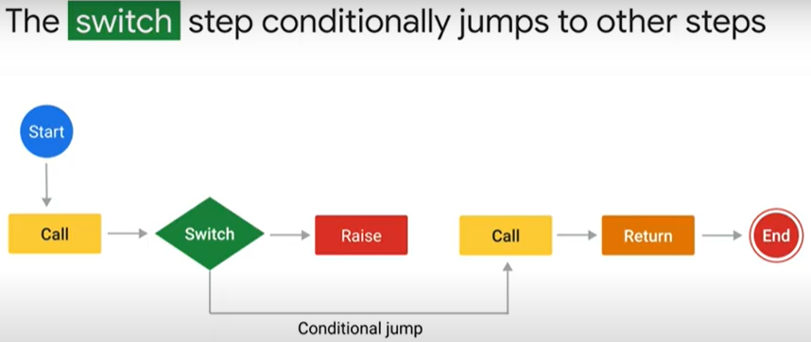
  + 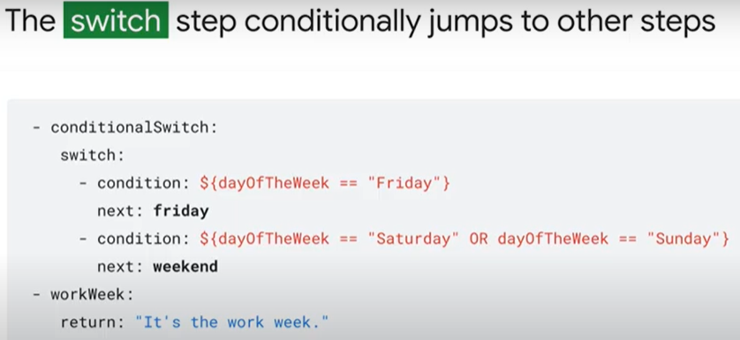 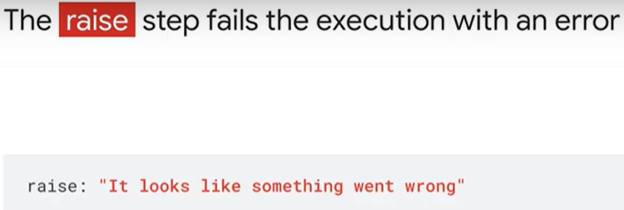
* Quiz
  + The maximum duration of a workflow execution is:
    - One year
  + Select statements that are true about Cloud Workflows (select all that apply):
    - You can use branching logic to create complex workflows
    - A workflow is a series of HTTP requests
  + Valid call steps in a Cloud Workflow include (Select all that apply):
    - Sleep for 5 seconds
    - Send a request to an external HTTPS URL